Chapter 7
Advanced Web Forms Programming
About This Chapter
In this chapter, you’ll learn how to perform some advanced programming tasks that don’t fit neatly into any other category. Although you can successfully create Web applications without knowing the topics covered in this chapter, the lessons found here are an important part of mainstream Web programming, and they will help complete your skill set.
Before You Begin
To complete the lessons in this chapter, you must:
- Be comfortable creating Web applications using server controls and server-side code.
- Be somewhat familiar with using Microsoft Windows dynamic-link libraries (DLLs) and Component Object Model (COM) objects in an earlier programming language such as Microsoft Visual Basic version 6.0.
- Have some experience with a scripting language, such as Microsoft Visual Basic, Scripting Edition (VBScript) or Microsoft JScript. If you’ve never used a scripting language, you should review the VBScript User’s Guide or JScript User’s Guide topics in the Microsoft Visual Studio online Help before beginning Lesson 4.
Lesson 1: Saving and Retrieving User Information
Web applications that require users to register information can retrieve that information whenever a particular user revisits the Web site. For example, a shopping Web site might record the user’s shipping and billing information and then retrieve that information to fill in address fields whenever that user places a new order.
After this lesson, you will be able to
- Explain how cookies make it possible to identify users and to store user information
- Store simple or complex information on a user’s computer through a cookie
- Remove a cookie from a user’s computer
- Create a unique identifier for a user and store it on his or her computer
- Use an XML file to store and retrieve information about a user based on that user’s unique identifier
Estimated lesson time: 35 minutes
Identifying Web Application Users
Web applications can identify users by requiring them to enter a user name and password whenever they visit the Web site. Web applications can also identify users through information stored on their computers in the form of cookies. Cookies are small files that a Web application can write to the client’s computer.
The advantage of using cookies is that the interaction happens invisibly to the user: users don’t have to log on every time they visit your Web site; their information just appears automatically when needed.
The disadvantage of using cookies is that users can set their browsers not to accept cookies. Some users don’t like the idea of Web sites storing information on their computers and possibly using that information to track their movements on the Internet. Therefore, you should always check to see whether a client accepts cookies before attempting to use them.
You can use two approaches when storing and retrieving user information through cookies:
- Store all the user information as a cookie on the client’s machine.
This approach is useful when the user information is simple and is not required on the server for any other tasks.
- Store an identification key on the client’s machine, and then retrieve user information from a data source on the server using that identification key.
This is the best approach for storing more extensive information.
The following sections describe how to save and retrieve user information using each of these approaches.
Storing User Information on the Client
To store a cookie on the client’s machine, follow these steps:
- Check whether the client supports cookies by using the Browser object’s Cookies property.
- If the client supports cookies, check whether the cookie already exists by using the Request object’s Cookies collection.
- If the cookie does not already exist, create a new cookie object using the HttpCookie class.
- Set the cookie object’s Value and Expiration properties.
- Add the cookie object to the Response object’s Cookies collection.
The following Page_Load event procedure demonstrates the preceding steps by creating a cookie that tracks the last time a user viewed a Web page. The code checks whether the user accepts cookies and either adds a cookie if this is the user’s first visit to the page or updates the cookie if the user has visited the page before.
Visual Basic .NET
Private Sub Page_Load(ByVal sender As System.Object, _
ByVal e As System.EventArgs) Handles MyBase.Load
' (1) Check if browser accepts cookies.
If Request.Browser.Cookies Then
' (2) If the cookie does not exist...
If Request.Cookies("LastVisit") Is Nothing Then
' (3) Create the cookie.
Dim cookLastVisit As New HttpCookie("LastVisit", _
DateTime.Now.ToString())
' (4) Set the expiration to tommorrow.
cookLastVisit.Expires = DateTime.Now.AddDays(1)
' (5) Add to cookies collection.
Response.Cookies.Add(cookLastVisit)
' Display message.
litMessage.Text = "This is your first visit."
Else
' Get the cookie.
Dim cookLastVisit As HttpCookie = Request.Cookies("LastVisit")
' Display a message showing time of last visit.
litMessage.Text = "You last visited this page: " & _
cookLastVisit.Value
' Update the cookie on the client.
Response.Cookies("LastVisit").Value = Now.ToString()
Response.Cookies("LastVisit").Expires = DateTime.Now.AddDays(1)
End If
Else
litMessage.Text = "Your browser does not accept cookies."
End If
End Sub
Visual C#
private void Page_Load(object sender, System.EventArgs e)
{
// (1) Check if browser accepts cookies.
if (Request.Browser.Cookies)
{
// (2) If the cookie does not exist...
if (Request.Cookies["LastVisit"] == null)
{
// (3) Create the cookie.
HttpCookie cookLastVisit = new HttpCookie("LastVisit",
DateTime.Now.ToString());
// (4) Set the expiration to tommorrow.
cookLastVisit.Expires = DateTime.Now.AddDays(1);
// (5) Add to cookies collection.
Response.Cookies.Add(cookLastVisit);
// Display message.
litMessage.Text = "This is your first visit.";
}
else
{
// Get the cookie.
HttpCookie cookLastVisit = Request.Cookies["LastVisit"];
// Display a message showing time of last visit.
litMessage.Text = "You last visited this page: " +
cookLastVisit.Value;
// Update the cookie on the client.
Response.Cookies["LastVisit"].Value =
DateTime.Now.ToString();
Response.Cookies["LastVisit"].Expires =
DateTime.Now.AddDays(1);
}
}
else
{
litMessage.Text = "Your browser does not accept cookies.";
}
}
Facts About Cookies
Cookies are case sensitive. For example, LastVisit is not the same cookie as Lastvisit. The Expires property specifies when the client’s machine can discard the cookie. By default, cookies expire when the user’s session ends. Setting Expires to the DateTime.MaxValue means that the cookie never expires.
You can remove the cookie from the client’s machine by resetting the Expires property to the current time. For example, the following code removes the LastVisit cookie from the client’s machine:
Visual Basic .NET
Private Sub butRemoveCookie_Click(ByVal sender As System.Object, _
ByVal e As System.EventArgs) Handles butRemoveCookie.Click
' Set cookie to expire immediately.
Response.Cookies("LastVisit").Expires = DateTime.Now
End Sub
Visual C#
private void butRemoveCookie_Click(object sender, System.EventArgs e)
{
// Set cookie to expire immediately.
Response.Cookies["LastVisit"].Expires = DateTime.Now;
}
Using Keys Within Cookies
You can save up to 4096 bytes of information in a single cookie, and you can identify information within a cookie using keys. For example, the following code saves the user’s name and address information as a cookie with individual keys:
Visual Basic .NET
Private Sub butOK_Click(ByVal sender As System.Object, _
ByVal e As System.EventArgs) Handles butOK.Click
' Create a cookie.
Dim cookUserInfo As New HttpCookie("UserInfo")
' Fill in the keys from the form data.
cookUserInfo("FirstName") = txtFirstName.Text
cookUserInfo("LastName") = txtLastName.Text
cookUserInfo("Street") = txtStreet.Text
cookUserInfo("City") = txtStreet.Text
cookUserInfo("State") = drpState.SelectedItem.Value
cookUserInfo("ZIP") = txtZIP.Text
' Set the expiration.
cookUserInfo.Expires = DateTime.Now.AddDays(30)
' Add the cookie.
Response.Cookies.Add(cookUserInfo)
End Sub
Visual C#
private void butOK_Click(object sender, System.EventArgs e)
{
// Create a cookie.
HttpCookie cookUserInfo = new HttpCookie("UserInfo");
// Fill in the keys from the form data.
cookUserInfo["FirstName"] = txtFirstName.Text;
cookUserInfo["LastName"] = txtLastName.Text;
cookUserInfo["Street"] = txtStreet.Text;
cookUserInfo["City"] = txtStreet.Text;
cookUserInfo["State"] = drpState.SelectedItem.Value;
cookUserInfo["ZIP"] = txtZIP.Text;
// Set the expiration.
cookUserInfo.Expires = DateTime.Now.AddDays(30);
// Add the cookie.
Response.Cookies.Add(cookUserInfo);
}
To get the values from keys stored in a cookie, simply use the key’s name, as shown in the following code:
Visual Basic .NET
Private Sub butGetData_Click(ByVal sender As System.Object, _
ByVal e As System.EventArgs) Handles butGetData.Click
' Get the cookie.
Dim cookUserInfo As HttpCookie = Request.Cookies("UserInfo")
' Fill in the fields.
txtFirstName.Text = cookUserInfo("FirstName")
txtLastName.Text = cookUserInfo("LastName")
txtStreet.Text = cookUserInfo("Street")
txtCity.Text = cookUserInfo("City")
drpState.SelectedItem.Value = cookUserInfo("State")
txtZIP.Text = cookUserInfo("ZIP")
End Sub
Visual C#
private void butGetData_Click(object sender, System.EventArgs e)
{
// Get the cookie.
HttpCookie cookUserInfo = Request.Cookies["UserInfo"];
// Fill in the fields.
txtFirstName.Text = cookUserInfo["FirstName"];
txtLastName.Text = cookUserInfo["LastName"];
txtStreet.Text = cookUserInfo["Street"];
txtCity.Text = cookUserInfo["City"];
drpState.SelectedItem.Value = cookUserInfo["State"];
txtZIP.Text = cookUserInfo["ZIP"];
}
Storing User Information on the Server
To store user information on the server instead of on the client’s machine, simply use cookies as an identification device to store and retrieve user information on the server. You can store user information on the server using a database, an XML file, or some other type of data store.
To store user information on the server, follow these steps:
- Create a unique key to identify the user.
- Save the unique key as a cookie on the user’s computer.
- Create a file on the server to store user information.
- Save the user information on the server using the unique key as an index.
The follow sections describe these steps in greater detail.
Creating Unique Keys to Identify Users
The Microsoft .NET Framework provides the System.Guid namespace for creating globally unique identifiers (GUIDs). A GUID is a 128-bit integer that serves as a unique identifier across networks. You can use GUIDs as unique keys to identify all sorts of things, including users.
The following code creates a GUID and stores it as a cookie on the client’s machine to later identify the user:
Visual Basic .NET
Private Sub butOK_Click(ByVal sender As System.Object, _
ByVal e As System.EventArgs) Handles butOK.Click
' Get the request cookie.
Dim cookUserID As HttpCookie = Request.Cookies("UserID")
' If it doesn't exist, create it.
If cookUserID Is Nothing Then
' Create a new cookie with a new GUID.
cookUserID = New HttpCookie("UserID", _
System.Guid.NewGuid().ToString())
cookUserID.Name = "UserID"
End If
' Set the expiration.
cookUserID.Expires = DateTime.Now.AddDays(30)
' Add the cookie to the response.
Response.Cookies.Add(cookUserID)
' Save the user info from the form data.
SetUserInfo(cookUserID.Value)
End Sub
Visual C#
private void butOK_Click(object sender, System.EventArgs e)
{
// Get the request cookie.
HttpCookie cookUserID = Request.Cookies["UserID"];
// If it doesn't exist, create it.
if (cookUserID == null)
// Create a new cookie with a new GUID.
cookUserID = new HttpCookie("UserID",
System.Guid.NewGuid().ToString());
// Set the expiration.
cookUserID.Expires = DateTime.Now.AddDays(30);
// Add the cookie to the response.
Response.Cookies.Add(cookUserID);
// Save the user info from the form data.
SetUserInfo(cookUserID.Value);
}
Creating a File to Store User Information
Part of the point of storing user information is to be able to retrieve that information quickly the next time the user visits your Web application. Because these users are already identified by a unique key (the GUID created in the preceding section), it makes sense that you will want to access their data through a data set. Data sets provide the Find method to retrieve rows of data by unique keys.
Using a data set means that the file you create on the server must be either a database or an XML file. XML provides a way to record structured data to a file without the complexity or overhead of a database, so for something as simple as user name and address information you’ll probably want to use XML.
To create an XML file to store user information, follow these steps:
- Create an XML file in Visual Studio containing test data for each of the data fields you want to record about the user.
- Generate an XML schema from the XML file. The XML schema enables the data set to refer to data in the XML file by name.
- Specify a key field within the XML schema. This will let you find records using that field with the data set’s Find method.
- Read the XML schema and XML file into a data set.
The following sections describe these steps in more detail.
Creating an XML File
To create an XML file in Visual Studio, choose Add New Item from the Project menu and then select XML File from the Templates list.
XML files look a lot like HTML files; however, XML elements and attributes are case sensitive and use a strict syntax. You use <element> and </element> tags to identify the data elements in an XML file. The following sample shows an XML file for storing user name and address information:
<?xml version="1.0" standalone="yes"?>
<USERS xmlns="http://tempuri.org/UserPrefs.xsd">
<USER>
<FIRSTNAME>Joan</FIRSTNAME>
<LASTNAME>Reddington</LASTNAME>
<STREET>436 Atlantic Ave.</STREET>
<CITY>Melbourne Beach</CITY>
<STATE>FL</STATE>
<ZIP>32401</ZIP>
<ID>79844302-6d86-4520-ac64-c8c3240e21a9</ID>
</USER>
</USERS>
Creating an XML Schema
To use an XML file with a data set, you must first create an XML schema for the data set. An XML schema is a description of the data elements contained in the XML file. It provides the names of the elements and their types, indicates whether they are key fields, and provides other information.
To create an XML schema from an XML file, select Create Schema from the XML menu while the XML file is displayed in the Design view. Visual Studio creates a schema file describing the XML file, as shown in Figure 7-1.
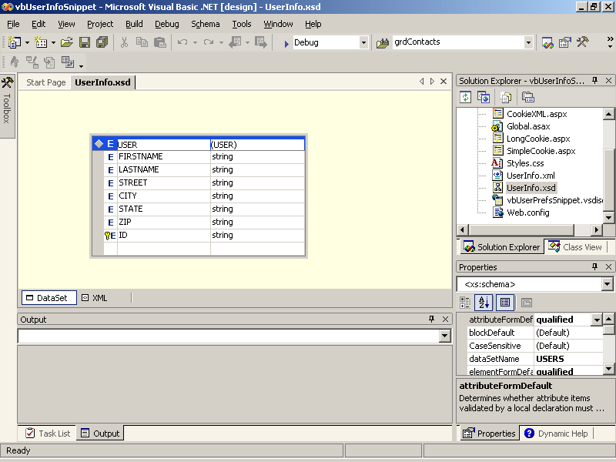
Figure 7-1. An XML schema
Specifying a Key Field
You add a primary key to the XML schema to enable searching. The schema shown in Figure 7-1 includes a key field that enables the data set to search for users by UserID.
To add a key field to the XML schema, follow these steps:
- Right-click the element to create a key, point to Add, and then select New Key from the shortcut menu. Visual Studio displays the Edit Key dialog box, as shown in Figure 7-2.
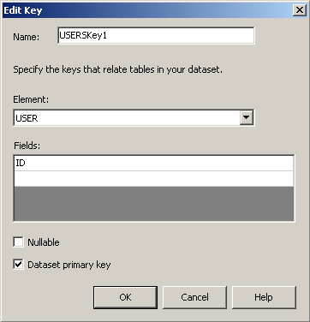
Figure 7-2. The Edit Key dialog box
- Select the Dataset Primary Key check box and click OK to make the element a primary key within the data set. This enables you to use the Dataset object’s Find method to retrieve rows from the data set using values for the element.
Reading the XML into a Data Set
When you’ve created an XML file and an XML schema, you can read those files into a data set using the ReadXmlSchema and ReadXml methods, respectively. The following code shows a helper function that returns a data set created from the UserInfo XML file:
Visual Basic .NET
Function GetUserData() As DataSet
' Set the path of the XML file and XML schema.
Dim strPath As String = Server.MapPath(".")
' Declare a data set.
Dim dsUsers As New DataSet()
' Apply the XML schema to the data set.
dsUsers.ReadXmlSchema(strPath & "\UserInfo.xsd")
' Read the XML into the data set.
dsUsers.ReadXml(strPath & "\UserInfo.xml")
Return dsUsers
End Function
Visual C#
private DataSet GetUserData()
{
// Set the path of the XML file and XML schema.
string strPath = Server.MapPath(".");
// Declare a data set.
DataSet dsUsers = new DataSet();
// Apply the XML schema to the data set.
dsUsers.ReadXmlSchema(strPath + "\\UserInfo.xsd");
// Read the XML into the data set.
dsUsers.ReadXml(strPath + "\\UserInfo.xml");
return dsUsers;
}
Saving User Information on the Server
To save user information on the server as an XML file, use the Dataset object’s SaveXML method. The following SetUserInfo procedure uses the GetUserData procedure described in the preceding section to get a data set from the XML file and then uses the Find method to check whether the UserID exists within that data set. If the UserID is not found, SetUserInfo adds a row for the user before setting the values for the fields in that row from server controls on a Web form. Finally, SetUserInfo writes the whole data set back to the server.
Visual Basic .NET
Sub SetUserInfo(ByVal UserID As String)
' Set the path of the XML file and XML schema.
Dim strPath As String = Server.MapPath(".")
' Get the User's data set.
Dim dsUsers As DataSet = GetUserData()
' Find the row in the data set.
Dim rowUser As DataRow = dsUsers.Tables("User").Rows.Find(UserID)
' If the row is not found, then create a new row.
If rowUser Is Nothing Then
rowUser = dsUsers.Tables("User").NewRow
dsUsers.Tables("User").Rows.Add(rowUser)
End If
' Save data from form fields.
rowUser("FirstName") = txtFirstName.Text
rowUser("LastName") = txtLastName.Text
rowUser("Street") = txtStreet.Text
rowUser("City") = txtCity.Text
rowUser("State") = drpState.SelectedItem.Text
rowUser("ZIP") = txtZIP.Text
rowUser("ID") = UserID
' Write the XML from the data set.
dsUsers.WriteXml(strPath & "\UserInfo.xml")
End Sub
Visual C#
private void SetUserInfo(string UserID)
{
// Set the path of the XML file and XML schema.
string strPath = Server.MapPath(".");
// Get the User's data set.
DataSet dsUsers = GetUserData();
// Find the row in the data set.
DataRow rowUser = dsUsers.Tables["User"].Rows.Find(UserID);
// If the row is not found, then create a new row.
if (rowUser == null)
{
rowUser = dsUsers.Tables["User"].NewRow();
dsUsers.Tables["User"].Rows.Add(rowUser);
}
// Save data from form fields.
rowUser["FirstName"] = txtFirstName.Text;
rowUser["LastName"] = txtLastName.Text;
rowUser["Street"] = txtStreet.Text;
rowUser["City"] = txtCity.Text;
rowUser["State"] = drpState.SelectedItem.Text;
rowUser["ZIP"] = txtZIP.Text;
rowUser["ID"] = UserID;
// Write the XML from the data set.
dsUsers.WriteXml(strPath + "\\UserInfo.xml");
}
Retrieving User Information from the Data Set
To retrieve user information from the XML file, use the GetUserData procedure to create a data set from the XML file, and then use the Find method to retrieve the row that corresponds to the UserID. The following GetUserInfo procedure retrieves user information from the data set and uses it to fill in server controls on a Web form:
Visual Basic .NET
Sub GetUserInfo(ByVal UserID As String)
' Get the User's data set.
Dim dsUsers As Data.DataSet = GetUserData()
' Find the row in the data set.
Dim rowUser As Data.DataRow = dsUsers.Tables("User").Rows.Find(UserID)
' If user wasn't found, exit.
If rowUser Is Nothing Then Exit Sub
' Add data to form fields.
txtFirstName.Text = rowUser.Item("FirstName")
txtLastName.Text = rowUser.Item("LastName")
txtStreet.Text = rowUser.Item("Street")
txtCity.Text = rowUser.Item("City")
drpState.SelectedItem.Text = rowUser.Item("State")
txtZIP.Text = rowUser.Item("ZIP")
End Sub
Visual C#
void GetUserInfo(string UserID)
{
// Get the User's data set.
DataSet dsUsers = GetUserData();
// Find the row in the data set.
DataRow rowUser = dsUsers.Tables["User"].Rows.Find(UserID);
// If user wasn't found, exit.
if (rowUser == null) return;
// Add data to form fields.
txtFirstName.Text = rowUser["FirstName"].ToString();
txtLastName.Text = rowUser["LastName"].ToString();
txtStreet.Text = rowUser["Street"].ToString();
txtCity.Text = rowUser["City"].ToString();
drpState.SelectedItem.Text = rowUser["State"].ToString();
txtZIP.Text = rowUser["ZIP"].ToString();
}
Lesson 2: Using Unmanaged Code
Microsoft ASP.NET Web applications run under the control of the common language runtime (CLR). The CLR controls how the application’s assembly executes, allocates, and recovers memory; therefore, ASP.NET applications are said to use managed code. In contrast, most other Windows executables use unmanaged code because the executable itself determines how memory is used.
Examples of unmanaged code include the Microsoft Win32 API, legacy DLLs and EXEs created for Windows applications prior to the Microsoft .NET Framework, and COM objects. In this lesson, you’ll learn how to declare and call unmanaged code at the procedure level from a .NET assembly. For information about calling COM objects from .NET, see Lesson 3.
After this lesson, you will be able to
- Declare an unmanaged procedure for use in a .NET assembly
- Call an unmanaged procedure with scalar parameter types
- Convert structure and object parameters between.NET and unmanaged types
- Catch and handle errors from unmanaged code within a .NET assembly
- Understand the limitations of using unmanaged code within a .NET assembly
Estimated lesson time: 30 minutes
Using Platform Invoke
The process of executing native code from within a .NET assembly is called platform invoke, or pinvoke for short. You use platform invoke to call the Win32 API directly, to access existing (legacy) DLLs your company uses, or to access procedures compiled to native code for performance reasons. To use platform invoke, follow these steps:
- Import the System.Runtime.InteropServices namespace.
- Declare the unmanaged procedure using the DllImport attribute or the Declare statement.
- Map the data types of the procedures parameters to the equivalent .NET types.
- Call the unmanaged procedure and test its return value for success.
- If the procedure did not succeed, retrieve and handle the exception code using the Marshal object’s GetLastWin32Error method.
For example, the following code declares the Win32 API’s GetSystemInfo procedure and then calls the unmanaged procedure to display information about the server’s processor on a Web form:
Visual Basic .NET
' (1) Import InteropServices namespace.
Imports System.Runtime.InteropServices

Public Class Win32API
Inherits System.Web.UI.Page

' (2) Use a Declare statement to identify an unmanaged procedure to call.
Declare Auto Sub GetSystemInfo Lib "kernel32.dll" (ByRef Info As SYSTEM_INFO)

' (3) Define Structs or other types for unmanaged procedure parameters.
Structure SYSTEM_INFO
Dim ProcessorArchitecture As Int16
Dim Reserved As Int16
Dim PageSize As Int32
Dim MinAppAddress As Int32
Dim MaxAppAddress As Int32
Dim ActiveProcMask As Int32
Dim NumberOfProcessors As Int32
Dim ProcessorType As Int32
Dim AllocGranularity As Int32
Dim ProcessorLevel As Int32
Dim ProcessorRevision As Int32
End Structure

Private Sub Page_Load(ByVal sender As System.Object, _
ByVal e As System.EventArgs) Handles MyBase.Load
' Declare the parameter to pass in.
Dim CurrentSystem As SYSTEM_INFO
' (4) Call the unmanaged procedure.
GetSystemInfo(CurrentSystem)
' Display results.
litSystemInfo.Text = "Number of processors: " + _
CurrentSystem.NumberOfProcessors.ToString() + "<br>"
litSystemInfo.Text += "Type of processor: " + _
CurrentSystem.ProcessorType.ToString() + "<br>"
litSystemInfo.Text += "Page size: " + _
CurrentSystem.PageSize.ToString() + "<br>"
End Sub

End Class
Visual C#
// (1) Use InteropServices namespace.
using System.Runtime.InteropServices;

public class Win32API : System.Web.UI.Page
{
protected System.Web.UI.WebControls.Literal litSystemInfo;

// (2) Identify an unmanaged procedure to call.
[DllImport("KERNEL32.DLL", EntryPoint="GetSystemInfo",
SetLastError=true,CharSet=CharSet.Unicode, ExactSpelling=true,
CallingConvention=CallingConvention.StdCall)]
public static extern void GetSystemInfo(ref SYSTEM_INFO Info);

// (3) Define types for unmanaged procedure parameters.
[StructLayout(LayoutKind.Sequential)] public struct SYSTEM_INFO
{
public Int16 ProcessorArchitecture ;
public Int16 Reserved ;
public Int32 PageSize ;
public Int32 MinAppAddress;
public Int32 MaxAppAddress ;
public Int32 ActiveProcMask ;
public Int32 NumberOfProcessors ;
public Int32 ProcessorType ;
public Int32 AllocGranularity ;
public Int32 ProcessorLevel ;
public Int32 ProcessorRevision ;
}

private void Page_Load(object sender, System.EventArgs e)
{
// Declare the parameter to pass in.
SYSTEM_INFO CurrentSystem;
// (4) Call unmanaged procedure.
GetSystemInfo(ref CurrentSystem);
litSystemInfo.Text = "Number of processors: " +
CurrentSystem.NumberOfProcessors.ToString() + "<br>";
litSystemInfo.Text += "Type of processor: " +
CurrentSystem.ProcessorType.ToString() + "<br>";
litSystemInfo.Text += "Page size: " +
CurrentSystem.PageSize.ToString() + "<br>";
}
}
In the preceding code, the Visual Basic .NET sample uses the Declare statement instead of the DllImport attribute. The Declare statement provides a simplified syntax for declaring unmanaged procedures, and it is converted to the following equivalent DllImport attribute code when compiled:
Visual Basic .NET
<DllImport("KERNEL32.DLL", EntryPoint:="GetSystemInfo", SetLastError:=True, _
CharSet:=CharSet.Unicode, ExactSpelling:=True, _
CallingConvention:=CallingConvention.StdCall)> _
Public Shared Sub GetSystemInfo(ByRef Info As SYSTEM_INFO)
' Leave procedure body empty
End Sub
You can use either form in your Visual Basic .NET code. Microsoft Visual C# supports only the DllImport form.
Converting Data Types
The .NET Framework uses a unified type system that is different from the types defined in the Win32 API. When you call an unmanaged procedure from a .NET assembly, the CLR collects the parameters and converts their types in a process called marshaling.
Scalar numeric types map between the two type systems based on their size in memory. So, for instance, a dword maps to an Int32, a word maps to an Int16, and so on. String data types in .NET are the equivalent of BSTRS in Win32. Strings are automatically converted between Unicode and ANSI formats if the DllImport attribute’s CharSet field is set to CharSet.Ansi.
Structures in .NET are defined in much the same way that they are for the Win32 API. By default, .NET structures are arranged sequentially in memory in the order in which they are defined within the structure declaration. You can also explicitly define how structures are ordered in memory using the StructLayout attribute. The following code shows two equivalent declarations of the SYSTEM_INFO structure using sequential and explicit layouts:
Visual Basic .NET
' Sequential (default) layout
<StructLayout(LayoutKind.Sequential)> Structure SYSTEM_INFO
Dim ProcessorArchitecture As Int16
Dim Reserved As Int16
Dim PageSize As Int32
Dim MinAppAddress As Int32
Dim MaxAppAddress As Int32
Dim ActiveProcMask As Int32
Dim NumberOfProcessors As Int32
Dim ProcessorType As Int32
Dim AllocGranularity As Int32
Dim ProcessorLevel As Int32
Dim ProcessorRevision As Int32
End Structure

' Equivalent explicit layout
<StructLayout(LayoutKind.Explicit)> Structure SYSTEM_INFO
<FieldOffset(0)> Dim ProcessorArchitecture As Int16
<FieldOffset(2)> Dim Reserved As Int16
<FieldOffset(4)> Dim PageSize As Int32
<FieldOffset(8)> Dim MinAppAddress As Int32
<FieldOffset(12)> Dim MaxAppAddress As Int32
<FieldOffset(16)> Dim ActiveProcMask As Int32
<FieldOffset(20)> Dim NumberOfProcessors As Int32
<FieldOffset(24)> Dim ProcessorType As Int32
<FieldOffset(28)> Dim AllocGranularity As Int32
<FieldOffset(32)> Dim ProcessorLevel As Int32
<FieldOffset(36)> Dim ProcessorRevision As Int32
End Structure
Visual C#
// Sequential (default) layout
[StructLayout(LayoutKind.Sequential)] public struct SYSTEM_INFO
{
public Int16 ProcessorArchitecture ;
public Int16 Reserved ;
public Int32 PageSize ;
public Int32 MinAppAddress;
public Int32 MaxAppAddress ;
public Int32 ActiveProcMask ;
public Int32 NumberOfProcessors ;
public Int32 ProcessorType ;
public Int32 AllocGranularity ;
public Int32 ProcessorLevel ;
public Int32 ProcessorRevision ;
}

// Equivalent explicit layout
[StructLayout(LayoutKind.Explicit)] public struct SYSTEM_INFO
{
[FieldOffset(0)]public Int16 ProcessorArchitecture ;
[FieldOffset(2)]public Int16 Reserved ;
[FieldOffset(4)]public Int32 PageSize ;
[FieldOffset(8)]public Int32 MinAppAddress;
[FieldOffset(12)]public Int32 MaxAppAddress ;
[FieldOffset(16)]public Int32 ActiveProcMask ;
[FieldOffset(20)]public Int32 NumberOfProcessors ;
[FieldOffset(24)]public Int32 ProcessorType ;
[FieldOffset(28)]public Int32 AllocGranularity ;
[FieldOffset(32)]public Int32 ProcessorLevel ;
[FieldOffset(36)]public Int32 ProcessorRevision ;
}
Declaring a layout is required when you’re passing objects to unmanaged code, because objects might be moved around in memory after they are created. The preceding code passed the SYSTEM_INFO structure by reference. Passing a structure by reference is equivalent to passing an object by value. The following code performs the same task, but passes an object by value rather than a structure by reference:
Visual Basic .NET
Public Class Win32API
Inherits System.Web.UI.Page

' Pass an object by value.
Declare Auto Sub GetSystemInfo Lib "kernel32.dll" _
(ByVal Info As SYSTEM_INFO)

Private Sub Page_Load(ByVal sender As System.Object, _
ByVal e As System.EventArgs) Handles MyBase.Load
' Create the object parameter to pass in.
Dim CurrentSystem As New SYSTEM_INFO
' Call the unmanaged procedure with a parameter by value.
GetSystemInfo(CurrentSystem)
' Display results.
litSystemInfo.Text = "Number of processors: " + _
CurrentSystem.NumberOfProcessors.ToString() + "<br>"
litSystemInfo.Text += "Type of processor: " + _
CurrentSystem.ProcessorType.ToString() + "<br>"
litSystemInfo.Text += "Page size: " + _
CurrentSystem.PageSize.ToString() + "<br>"
End Sub
End Class

' Define a class with a sequential layout.
<StructLayout(LayoutKind.Sequential)> Public Class SYSTEM_INFO
Dim ProcessorArchitecture As Int16
Dim Reserved As Int16
Public PageSize As Int32
Dim MinAppAddress As Int32
Dim MaxAppAddress As Int32
Dim ActiveProcMask As Int32
Public NumberOfProcessors As Int32
Public ProcessorType As Int32
Dim AllocGranularity As Int32
Dim ProcessorLevel As Int32
Dim ProcessorRevision As Int32
End Class
Visual C#
public class Win32API : System.Web.UI.Page
{
protected System.Web.UI.WebControls.Literal litSystemInfo;

// Pass an object by value.
[DllImport("KERNEL32.DLL", EntryPoint="GetSystemInfo",
SetLastError=true,CharSet=CharSet.Unicode, ExactSpelling=true,
CallingConvention=CallingConvention.StdCall)]
public static extern void GetSystemInfo(SYSTEM_INFO Info);

private void Page_Load(object sender, System.EventArgs e)
{
// Create the object to pass in.
SYSTEM_INFO CurrentSystem = new SYSTEM_INFO();
// Call an unmanaged procedure with a parameter by value.
GetSystemInfo(CurrentSystem);
litSystemInfo.Text = "Number of processors: " +
CurrentSystem.NumberOfProcessors.ToString() + "<br>";
litSystemInfo.Text += "Type of processor: " +
CurrentSystem.ProcessorType.ToString() + "<br>";
litSystemInfo.Text += "Page size: " +
CurrentSystem.PageSize.ToString() + "<br>";
}
}

// Define a class with a sequential layout.
[StructLayout(LayoutKind.Sequential)] public class SYSTEM_INFO
{
public Int16 ProcessorArchitecture ;
public Int16 Reserved ;
public Int32 PageSize ;
public Int32 MinAppAddress;
public Int32 MaxAppAddress ;
public Int32 ActiveProcMask ;
public Int32 NumberOfProcessors ;
public Int32 ProcessorType ;
public Int32 AllocGranularity ;
public Int32 ProcessorLevel ;
public Int32 ProcessorRevision ;
}
This section covered passing only the most common types of parameters to unmanaged procedures. An exhaustive list of the different possible types along with samples of how to pass them can be found in the Visual Studio .NET Help topic “Marshaling Data with Platform Invoke.”
Handling Exceptions from Unmanaged Procedures
Unmanaged procedures typically return a value that indicates whether an exception occurred during their execution. Nonzero return values usually indicate success, and a zero return value usually indicates that an exception occurred. To handle exceptions from unmanaged code, follow these steps:
- Declare the unmanaged procedure with the SetLastError field set to True/true. This is the default used by the Visual Basic .NET Declare statement.
- Check the returned value from the unmanaged procedure.
- If the procedure returned 0, get the unmanaged exception code using the Marshal object’s GetLastWin32Error method.
- Compare the exception code to a list of possible values.
For example, the following code uses the Win32 API MoveFile method and displays an appropriate error message for some of the possible exceptions:
Visual Basic .NET
' Declare an unmanaged procedure.
Declare Auto Function MoveFile Lib "kernel32.dll" (ByVal src As String, _
ByVal dst As String) As Boolean

Private Sub Page_Load(ByVal sender As System.Object, _
ByVal e As System.EventArgs) Handles MyBase.Load
' Call MoveFile on a read-only file to cause an error.
If MoveFile(Server.MapPath(".\") + "protected.txt", _
"newfile.txt") = True Then
litStatus.Text = "File moved."
Else
' MoveTo returns False if there is an error.
Dim msg As String
' Set a message depending on error code returned.
Select Case Marshal.GetLastWin32Error
Case 2
msg = "File not found."
Case 3
msg = "Path not found."
Case 5
msg = "Access denied."
Case 15
msg = "Drive not found."
Case Else
msg = "Unlisted error."
End Select
' Display error.
litStatus.Text = "The following error occurred: <br>" + msg
End If
End Sub
Visual C#
[DllImport("KERNEL32.DLL", EntryPoint="MoveFile",
SetLastError=true,CharSet=CharSet.Unicode, ExactSpelling=false,
CallingConvention=CallingConvention.StdCall)]
public static extern bool MoveFile(string src, string dest);

private void Page_Load(object sender, System.EventArgs e)
{
// Call MoveFile on a read-only file to cause an error.
if (MoveFile(Server.MapPath(".\\") + "protected.txt", "newfile.txt"))
{
litStatus.Text = "File moved.";
}
else
{
// MoveTo returns False if there is an error.
string msg ;
// Set a message depending on error code returned.
switch (Marshal.GetLastWin32Error())
{
case 2:
msg = "File not found.";
break;
case 3:
msg = "Path not found.";
break;
case 5:
msg = "Access denied.";
break;
case 15:
msg = "Drive not found.";
break;
default:
msg = "Unlisted error.";
break;
}
// Display error.
litStatus.Text = "The following error occurred: <br>" + msg;
}
}
Limitations of Unmanaged Code
The .NET Framework adds many features that are either not available or implemented differently in unmanaged procedures. You should be aware of the following limitations whenever you start using unmanaged code from within a .NET assembly:
- Performance
Although native-code DLLs can perform some operations more quickly than equivalent code managed by the CLR, these benefits might be offset by the time it takes to marshal the data to pass between the unmanaged procedure and the .NET assembly.
- Type safety
Unlike .NET assemblies, unmanaged procedures might not be type-safe. This can affect the reliability of your .NET application. In general, reliability is a paramount concern with ASP.NET Web applications.
- Code security
Unmanaged procedures do not use the .NET Framework’s model for code security.
- Versioning
Unmanaged code does not support .NET versioning; therefore, assemblies that call unmanaged procedures might lose the benefit of being able to coexist with other versions of the same assembly.
Lesson 3: Interoperating with COM
COM objects are another type of unmanaged code that you can use from .NET assemblies. Because COM is widely used, Visual Studio includes built-in tools for importing and using COM objects within .NET assemblies. Visual Studio also includes the option of automatically registering .NET class library assemblies for use from COM.
In this lesson, you’ll learn both sides of the equation: how to use COM objects from .NET, and how to create .NET objects for use from COM. Together, these techniques allow you to integrate ASP.NET Web applications into existing software architecture.
After this lesson, you will be able to
- Create references to COM objects and use them from .NET code
- Register .NET class libraries for use from COM
- Selectively hide or expose public members of a .NET assembly for use with COM
- Handle exceptions that occur between .NET and COM objects
- Understand the limitations of using .NET objects from COM and of using COM objects from .NET
Estimated lesson time: 20 minutes
Using COM Objects from .NET
To use a COM object from a .NET assembly in Visual Studio, follow these steps:
- Install and register the COM object on your system.
- Open the .NET project in Visual Studio, and add a reference to the COM object, as shown in Figure 7-3. If the COM object does not appear on the COM tab of the Add Reference dialog box, you can add a reference directly to the executable by clicking Browse.
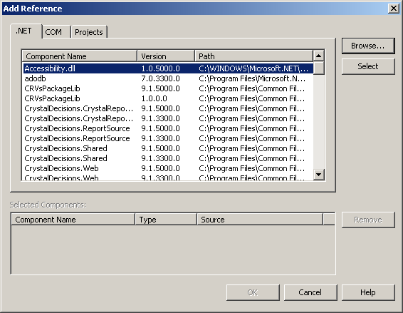
Figure 7-3. Adding a reference to a COM object
- Create an instance of the COM object in code, and use it as you would any other object.
When you add a reference to a COM object, Visual Studio automatically generates an interop assembly for the object and places it in the project’s /bin folder. The interop assembly is created from the COM object’s type information and contains the metadata that the CLR uses to call the unmanaged code in the COM object.
You can view this interop assembly using the Microsoft Intermediate Language Disassembler (Ildasm.exe) included in the .NET Framework. Figure 7-4 shows the interop assembly generated for a simple COM object named ShapesCOM.
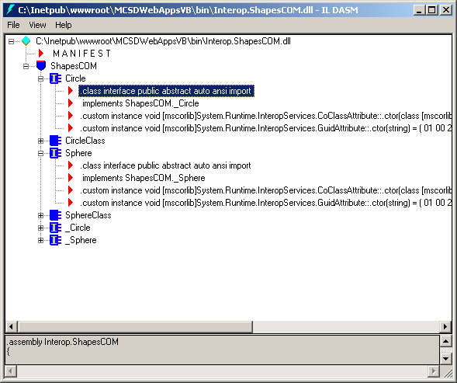
Figure 7-4. Viewing the interop assembly
You use COM objects from within .NET code the same way that you use .NET classes. For example, the following code creates instances of the Circle and Sphere COM objects and uses some of their members:
Visual Basic .NET
Private Sub butCalc_Click(ByVal sender As System.Object, _
ByVal e As System.EventArgs) Handles butCalc.Click
' Create a Circle COM object.
Dim Circle As New ShapesCOM.Circle
' Set the property.
Circle.Radius = CSng(txtRadius.Text)
' Call the method.
lblArea.Text = Circle.Area.ToString()
' Create a Sphere COM object.
Dim Sphere As New ShapesCOM.Sphere
' Set the property.
Sphere.Radius = CSng(txtRadius.Text)
' Call method.
lblVolume.Text = Sphere.Volume.ToString()
End Sub
Visual C#
private void butCalc_Click(object sender, System.EventArgs e)
{
// Create a Circle COM object.
ShapesCOM.Circle Circle = new ShapesCOM.Circle();
// Set the property.
float fRadius = System.Convert.ToSingle(txtRadius.Text);
Circle.Radius = fRadius;
// Call the method.
lblArea.Text = Circle.Area().ToString();
// Create a Sphere COM object.
ShapesCOM.Sphere Sphere = new ShapesCOM.Sphere();
// Set the property.
Sphere.Radius = fRadius;
// Call the method.
lblVolume.Text = Sphere.Volume().ToString();
}
NOTE
Visual Basic 6.0 allowed you to create COM properties (Property Let procedures) that were assigned by reference. Visual C# won’t recognize those properties. To use COM properties from Visual C#, they must be assigned by value.
Building .NET Objects for Use from COM
Visual Studio can automatically generate type library information and register a .NET class library assembly for use from COM. These automatic tools do not work for ASP.NET Web applications, so you must isolate the code you want to use from COM in its own Class Library project.
To create .NET objects for use with COM, follow these steps:
- Create a .NET class library project containing the objects you want to use from COM.
- In the project’s Build options, select the Register For COM Interop check box, as shown in Figures 7-5 and 7-6.
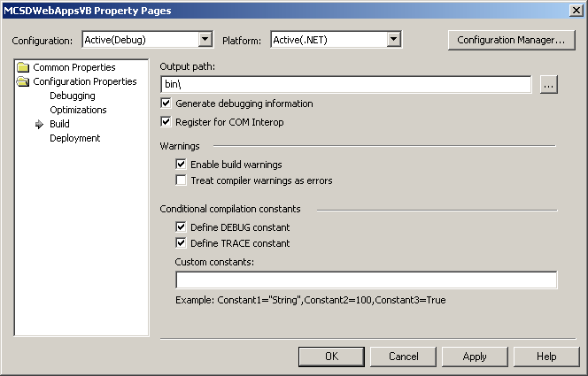
Figure 7-5. Registering a Visual Basic .NET project for COM interop
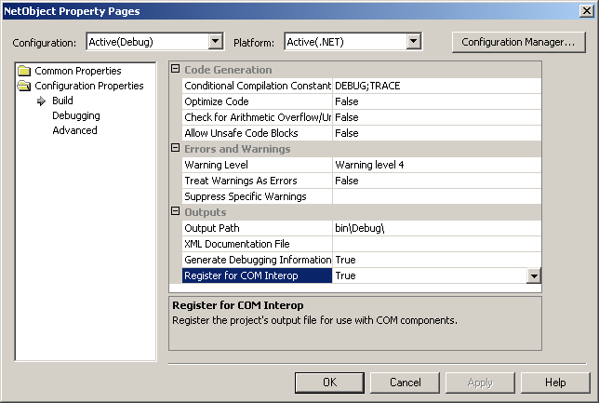
Figure 7-6. Registering a Visual C# project for COM interop
- Build the project.
When you register a project for COM interop, Visual Studio automatically creates a type library for the public classes and members in the .NET assembly and registers those classes with the system registry.
Hiding Public .NET Classes from COM
In some cases, you might want to hide selected .NET classes from COM but keep them public for use from other .NET assemblies. The ComVisible attribute allows you to select which public .NET classes and members are included in the generated type library. This attribute applies hierarchically for the assembly, class, and member levels. For example, the following code hides all public classes in the assembly, exposes the Circle and Sphere classes, and hides the Sphere class’s Center method:
Visual Basic .NET
' From AssemblyInfo.vb
' Hide public members from COM by default.
<Assembly: ComVisible(False)>

' From Shapes.vb
Imports System.Runtime.InteropServices

' Interface for all shapes.
Public Interface IFigure
Property Top() As Single
Property Left() As Single
Function Area() As Single
Function Perimeter() As Single
End Interface

' Definition of abstract class.
<ComVisible(True)> Public MustInherit Class Shape
Implements IFigure
Public MustOverride Property Top() As Single Implements IFigure.Top
Public MustOverride Property Left() As Single Implements IFigure.Left
Public MustOverride Function Area() As Single Implements IFigure.Area
Public MustOverride Function Perimeter() As Single
Implements IFigure.Perimeter
End Class

<ComVisible(True)> Public Class Circle
Inherits Shape
Private sxCenter, syCenter As Single
Private sRadius As Single

Public Overrides Property Top() As Single
Get
Top = sxCenter - sRadius
End Get
Set(ByVal Value As Single)
sxCenter = Value + sRadius
End Set
End Property

Public Overrides Property Left() As Single
Get
Left = syCenter - sRadius
End Get
Set(ByVal Value As Single)
syCenter = Value + sRadius
End Set
End Property

Public Overrides Function Area() As Single
Area = 2 * System.Math.PI * (sRadius ^ 2)
End Function

Public Overrides Function Perimeter() As Single
Perimeter = 2 * sRadius * System.Math.PI
End Function

Public Property Radius() As Single
Get
Radius = sRadius
End Get
Set(ByVal Value As Single)
sRadius = Value
End Set
End Property

Public Overridable Sub Center(ByVal X As Single, ByVal Y As Single)
sxCenter = X
syCenter = Y
End Sub
End Class

<ComVisible(True)> Public Class Sphere
Inherits Circle
Private sCenter As Single

Public Overrides Function Area() As Single
Area = 4 * System.Math.PI * (MyBase.Radius ^ 2)
End Function

<ComVisible(False)> Public Shadows Sub Center(ByVal X As Single, _
ByVal Y As Single, ByVal Z As Single)
MyBase.Center(X, Y)
sCenter = Z
End Sub

Public Function Volume() As Single
Volume = (4 / 3) * System.Math.PI * (Radius ^ 3)
End Function

Public Property Front() As Single
Get
Return sCenter - Radius
End Get
Set(ByVal Value As Single)
sCenter = Value + MyBase.Radius
End Set
End Property
End Class
Visual C#
// From AssemblyInfo.cs
// Hide public members from COM by default.
[assembly: ComVisible(false)]

// From Shapes.cs
[ComVisible(true)]public class Sphere : Circle
{
float fCenter;

// Constructor.
public Sphere()
{
// Initialize internal variable.
fCenter = 0;
}

public override float Area()
{
return (float)(4 * Math.PI * Math.Pow((double)base.Radius, 2));
}

[ComVisible(false)]public new void Center(float X, float Y)
{
this.Center(X, Y, 0);
}

[ComVisible(false)]public void Center(float X, float Y, float Z)
{
base.Center(X, Y);
fCenter = Z;
}

public float Volume()
{
return (float)((4 / 3) * System.Math.PI *
Math.Pow((double)base.Radius, 3));
}

public float Depth
{
get
{
return fCenter - base.Radius;
}
set
{
fCenter = value + base.Radius;
}
}
}

[ComVisible(true)] public class Circle : Shape
{
float fxCenter, fyCenter, fRadius;

// Constructor.
public Circle()
{
// Initialize internal variables.
fxCenter = 0;
fyCenter = 0;
fRadius = 0;
}

public override float Top
{
get
{
return fxCenter - fRadius;
}
set
{
fxCenter = value + fRadius;
}
}

public override float Left
{
get
{
return fyCenter - fRadius;
}
set
{
fyCenter = value + fRadius;
}
}

public override float Area()
{
return (float)(2 * System.Math.PI *
Math.Pow((double)fRadius, 2));
}

public override float Perimeter()
{
return 2 * fRadius * (float)System.Math.PI;
}

public float Radius
{
get
{
return fRadius;
}
set
{
fRadius = value;
}
}

public virtual void Center(float X, float Y)
{
fxCenter = X;
fyCenter = Y;
}

}

[ComVisible(true)] public abstract class Shape : IFigure
{

// Constructor.
public Shape()
{
}

public abstract float Top
{
get;
set;
}

public abstract float Left
{
get;
set;
}

public abstract float Area();

public abstract float Perimeter();

}

public interface IFigure
{
float Top
{
get;
set;
}

float Left
{
get;
set;
}

float Area();

float Perimeter();
}
Notice that the Shape abstract class in the preceding code is visible to COM. Although Shape is not a creatable class and thus can’t be used from COM, it must be visible to enable the use of its derived classes (Circle and Sphere) from COM.
Tools Used by COM Interop
Visual Studio automatically generates the interop assembly, type libraries, and other information for .NET to COM interoperation. Alternatively, you can use the command-line tools included with the .NET Framework and described in Table 7-1.
Table 7-1. COM Interop Tools
Tool | File name | Use to
Type Library Importer | Tlbimp.exe | Generate a .NET interop assembly for a COM object
Type Library Exporter | Tlbexp.exe | Generate a COM type library from a .NET assembly
Intermediate Language Disassembler | Ildasm.exe | View the generated interop assembly or other .NET assemblies
Assembly Registration Tool | Regasm.exe | Add or remove system registration database entries for a .NET assembly
Registry Editor | Regedit.exe | View system registry database entries for COM objects installed on a system, including .NET objects registered for COM interop
Handling Exceptions Between .NET and COM
.NET handles errors through exception classes. COM handles errors through 32-bit data types called HRESULTs. All of the .NET exception classes include HResult properties that map to COM HRESULT codes.
If an exception occurs in a .NET object, the exception is automatically mapped to the appropriate HRESULT and returned to COM. Similarly, if an exception occurs in a COM object, the COM HRESULT is mapped to the appropriate exception class, which is returned to .NET, where it can be handled just like any other exception.
If you are creating your own .NET exception classes for use with COM, be sure to set the class’s HResult property so that the exception can be handled within COM.
Limitations of COM Interop
The .NET Framework was developed to address the limitations of COM. Because of this evolution, there are limits to the .NET features that you can use from COM. The following list describes these limits:
- Shared/static members
COM requires objects to be created before use, so it does not support .NET Shared/static members.
- Shadows/new members
COM flattens the inheritance tree of .NET objects, so members in a derived class that shadow members inherited from a base class are not callable.
- Constructors with parameters
COM can’t pass parameters to an object’s constructor.
In addition to these technical limitations, you should also be aware of these practical limitations when using COM objects from .NET:
- Shared solutions might not allow COM objects.
ASP.NET host service providers that use nondedicated servers can limit or prohibit the installation of COM objects on their servers.
- COM objects are prone to memory leaks.
COM uses reference counting to determine when to destroy objects and free memory. It is possible for this reference count to become incorrect, leaving objects in memory indefinitely.
- Type libraries might be inaccurate.
Because COM separates the object’s description from its implementation, it’s possible for this description to not accurately reflect the object. In this case, the generated interop assembly will also include those inaccuracies.
- COM is unmanaged code.
The limitations cited for unmanaged procedures in Lesson 2 apply to COM objects as well.
Lesson 4: Using Client-Side Scripts
ASP.NET provides a full set of programming tools for creating Web applications that run on servers, so why should you worry about adding scripts to run on the client’s computer? Because scripts have direct access to the client’s browser, they make it possible to do many things you can’t do from server-side code. For example, you can use client-side scripts to perform the following tasks:
- Control the browser window.
You can’t control the browser from server-side code. To open new windows, set focus within a window, navigate between frames, navigate within history, and perform other browser-related tasks, you must use client-side scripts.
- Respond immediately to mouse-over events.
Server-side code can respond to events only after the page is posted back to the server; client-side code can respond to page events as they occur.
- Start the client’s mail system.
You can send mail from the client using the Mailto protocol. Additionally, you can send mail from the server using the SmtpMail class.
In this lesson, you’ll learn how to add scripts to Web forms and HTML pages in Visual Studio to create code that executes on the client’s computer.
After this lesson, you will be able to
- Test a browser to see whether it can run scripts
- Choose a scripting language that suits your needs
- Use objects provided by the Document Object Model (DOM) to control the browser window and the documents it contains
- Create scripts that run inline as the page is interpreted by the browser
- Create scripts that respond to events in the browser, such as mouse clicks and mouse-move events
- Get input from the user and display a response using scripts
- Send mail from either the client or server
Estimated lesson time: 30 minutes
Before You Use Scripts
Client-side scripts pose three issues you should be aware of:
- Not all browsers support scripting.
- Only Microsoft Internet Explorer supports VBScript.
- Scripting poses security concerns.
Because not all browsers support scripts, you should check the browser capabilities before displaying pages that contain client-side scripts. The following Page_Load event procedure checks whether a browser supports scripts and redirects users to a page recommending they download a new version if their browser does not support scripts:
Visual Basic .NET
Private Sub Page_Load(ByVal sender As System.Object, _
ByVal e As System.EventArgs) Handles MyBase.Load
If Request.Browser.VBScript Then
Response.Redirect("VBScripts.htm")
Exit Sub
ElseIf Request.Browser.JavaScript Then
Response.Redirect ("JScripts.htm")
Else
Response.Redirect("NoScripts.htm")
End If
End Sub
Visual C#
private void Page_Load(object sender, System.EventArgs e)
{
if (Request.Browser.VBScript)
Response.Redirect("VBScripts.htm");
else if (Request.Browser.JavaScript)
Response.Redirect("JScripts.htm");
else
Response.Redirect("NoScripts.htm");
}
Another concern with client-side scripts is security. There are two aspects to this issue. First, your scripts are not secure—they can be viewed or copied by anyone visiting your application. Second, scripts can potentially spread viruses; therefore, some users set their browser security settings to disable scripts.
The Browser object’s VBScript and JavaScript properties will return True, even if scripting has been disabled. To check whether scripting is enabled, you need to be a little clever. The following HTML tests whether scripting is enabled by trying to run a script. If scripting is enabled, the user is redirected to another page and he or she never sees the message that follows the script.
<html>
<script>
window.navigate("scripts.aspx")
</script>
<!-- If scripting is enabled, the following is never displayed -->
<head>
<title>Scripts</title>
</head>
<body MS_POSITIONING="FlowLayout">
<h2>Scripting is turned off.</h2>
<p>Your Internet security options specify that your browser will not run
scripts, and therefore you cannot view the page you requested. To turn
scripting on, reset your browser's Internet security options to Medium, or enable active scripting in the custom security settings.</p>
<p><a href="CheckBrowser.htm">Click here</a> to try again.</p>
</body>
</html>
Choosing a Scripting Language
Client-side scripts can be written in either VBScript or JScript. Scripting languages have the following differences from compiled languages, such as Visual Basic .NET or Visual C#:
- Script languages are not compiled.
Instead, they are interpreted by the browser at run time.
- Script keywords are a “safe subset” of their parent languages.
Scripts don’t allow you to create or delete files on the user’s disk or to perform tasks that obviously risk crashing the user’s computer.
Both VBScript and JScript are functionally equivalent—they differ only in syntax and keywords. In general, Visual C# programmers are more comfortable using JScript because it follows the C conventions; Visual Basic programmers are more comfortable using VBScript because it is closely related to Visual Basic. However, only Internet Explorer supports VBScript, so if your application needs to run on other browsers, you should use JScript.
If you are a Visual Basic programmer, you will probably not like the fact that JScript is case sensitive. In JScript, all keywords, variables, object references, methods, and properties must be correctly capitalized in order to work.
For more information about the scripting languages, see the following Visual Studio online Help topics:
- JScript User’s Guide
- JScript Language Reference
- VBScript User’s Guide
- VBScript Language Reference
Understanding the DOM
The Document Object Model (DOM) is made up of the objects that the browser provides for scripting. These objects let you control the browser window, the current page (or document), and objects on the page. Figure 7-7 shows the objects provided by the DOM.
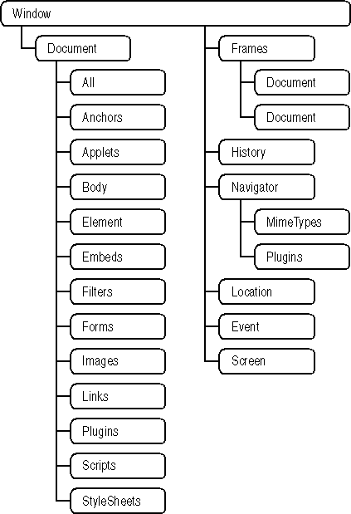
Figure 7-7. The DOM object hierarchy
Explaining all the objects in the DOM is outside the scope of this book. However, a great deal of information is available in the Visual Studio online Help in the “DHTML References” topic. That topic and the references it links to are part of the Web Workshop online Help.
Adding Inline Scripts
Web pages can include scripts inline as part of their content or as procedures that run in response to events. Inline scripts run the moment the browser encounters them. The example in the preceding section shows how this works by redirecting the browser to a new page if the browser allows scripting:
<html>
<script>
window.navigate("scripts.aspx")
</script>
<!-- If scripting is enabled, the markup that follows
this code is never displayed -->
<head>
<title>Scripts</title>
</head>
<body MS_POSITIONING="FlowLayout" onunload="return window_onunload()">
<h2>Scripting is turned off.</h2>
<p>Your Internet security options specify that your browser will
not run scripts, and therefore you cannot view the page you requested.
To turn scripting on, reset your browser's Internet security
options to Medium, or enable active scripting in the custom security
settings.</p>
<p><a href="CheckBrowser.htm">Click here</a> to try again.</p>
</body>
</html>
If this script successfully runs, the user never sees the message that scripting is turned off because the script runs before any page content. If an inline script refers to an element on the page, that element must appear before the script refers to it. For example, the following HTML displays two text boxes and uses a script to move the cursor to the second text box:
VBScript
<HTML>
<body language="vbscript">
<form id="Form1" method="post" runat="server">
<P>
<asp:TextBox id="txtFirstName" Runat="server"></asp:TextBox>
</P>
<P>
<asp:TextBox id="txtLastName" Runat="server"></asp:TextBox>
</P>
<script>window.document.all("txtLastName").focus()</script>
</form>
</body>
</HTML>
JScript
<HTML>
<body language="javascript">
<form id="Form1" method="post" runat="server">
<P>
<asp:TextBox id="txtFirstName" Runat="server"></asp:TextBox>
</P>
<P>
<asp:TextBox id="txtLastName" Runat="server"></asp:TextBox>
</P>
<script>window.document.all["txtLastName"].focus()</script>
</form>
</body>
</HTML>
Inline scripts can also be used as attributes of HTML elements that perform actions, such as the HTML Button control. For example, the following HTML creates a button that opens a Help page in a new window:
<button id="butHelp" onclick="window.open('help.aspx', 'help',
'height=200,width=300')">Help</button>
Notice that the preceding inline script is language-neutral—in other words, it will work whether the language attribute of the <body> element is set to VBScript or JScript. To use a scripting language other that the one set in the <body> element, you need to set the <script> element’s language attribute. For example, the following scripts display a list of heading levels:
VBScript
<HTML>
<script language="vbscript">
For i = 1 to 6
document.write("<h" & i & ">")
document.write("H" & i)
document.write("</h" & i & "><br>")
Next
</script>
</HTML>
JScript
<HTML>
<script language="javascript">
for (i = 1; i <= 6; i++)
{
document.write("<h" + i + ">");
document.write("H" + i);
document.write("</h" + i + "><br>");
}
</script>
</HTML>
The preceding code displays the six HTML heading levels, as shown in Figure 7-8.
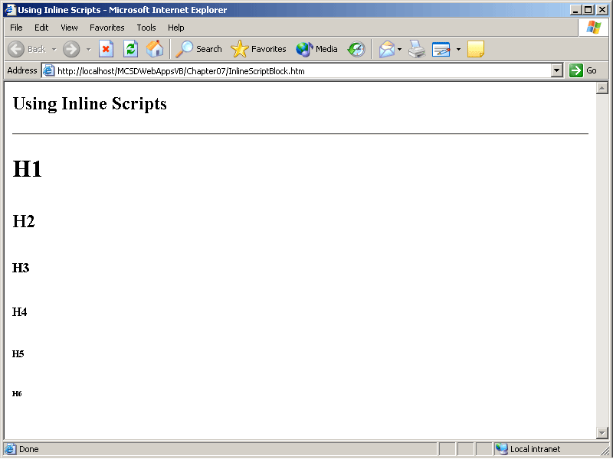
Figure 7-8. Inline scripts
Responding to Events with Script Procedures
Scripts also define procedures that respond to page events, such as the window loading, the buttons being clicked, and the mouse passing over objects.
To create a script event procedure, follow these steps:
- Using Visual Studio, create or open the page for which you want to include the client-side scripts. The page can be a Web form (.aspx) or an HTML page (.htm).
- Switch to the HTML view of the page.
- From the drop-down list at the top left of the page, select the object for which you want to add the event procedure, as shown in Figure 7-9.
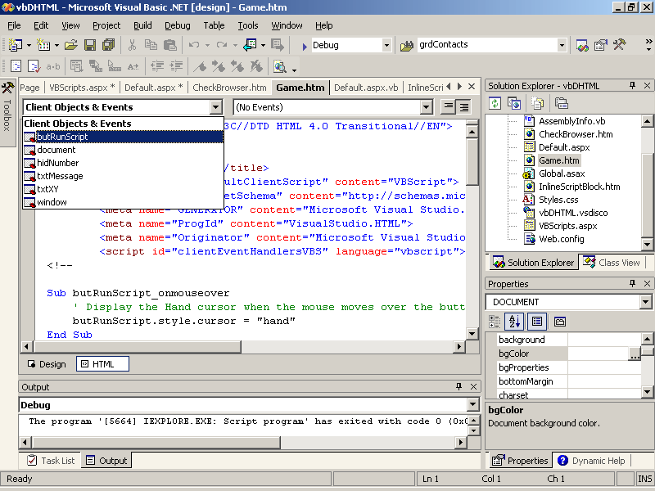
Figure 7-9. Selecting the object
- From the drop-down list at the top right of the page, select the event that you want the code to respond to, as shown in Figure 7-10.
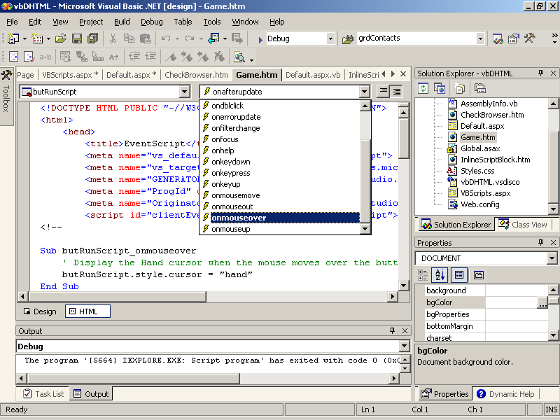
Figure 7-10. Selecting the event
Visual Studio creates a script block containing an empty event procedure, as shown in the following code:
VBScript
<script id=clientEventHandlersVBS language=vbscript>
<!--

Sub butRunScript_onmouseover

End Sub

-->
</script>
JScript
<script id=clientEventHandlersJS language=javascript>
<!--

function butRunScript_onmouseover() {

}

//-->
</script>
Any code you add to the event procedure will run when that page event occurs. For example, the following code switches the mouse cursor to the hand symbol when the user moves the mouse over the button:
VBScript
Sub butRunScript_onmouseover
butRunScript.style.cursor = "hand"
End Sub
JScript
function butRunScript_onmouseover() {
// Display the Hand cursor when the mouse moves over the button.
butRunScript.style.cursor = "hand";
}
Client-side event procedures can detect a wide variety of events, including keypresses, mouse-over events, clicks, loads, and unloads. Unlike server-side events, client-side events do not provide arguments directly. Instead, you use the window object’s event method to get values. For example, the following mousemove event procedure displays the coordinates of the cursor in the browser’s status bar:
VBScript
Sub document_onmousemove
' Display X, Y coordinates as the mouse moves across the browser window.
window.status = window.event.clientX & ", " & window.event.clientY
End Sub
JScript
function window_onmousemove() {
// Display X, Y coordinates as the mouse moves across the browser window.
window.status = window.event.clientX + ", " + window.event.clientY;
}
The code in client-side event procedures can get and set the values displayed in server and HTML controls on the page. This means that you can get values from the user and provide responses without posting the page back to the server. For example, the following HTML code defines a page that plays a simple game with the user—all without posting back to the server:
VBScript
<!DOCTYPE HTML PUBLIC "-//W3C//DTD HTML 4.0 Transitional//EN">
<html>
<head>
<title>EventScript</title>
<meta name="vs_defaultClientScript" content="VBScript">
<meta name="vs_targetSchema"
content="http://schemas.microsoft.com/intellisense/ie5">
<meta name="GENERATOR" content="Microsoft Visual Studio.NET 7.0">
<meta name="ProgId" content="VisualStudio.HTML">
<meta name="Originator" content="Microsoft Visual Studio.NET 7.0">
<script id="clientEventHandlersVBS" language="vbscript">

Sub butRunScript_onclick
' Display a message in a text area.
sMessage = "I am thinking of a number between 0 and 9. "
sMessage = sMessage & "Press a number key to take a guess."
txtMessage.value = sMessage
' Initialize the random number generator.
Randomize
' Get a random number and store it in a hidden field.
hidNumber.value = Int(9 * Rnd)
End Sub

Sub document_onkeypress
' If the keypress matches the number, display a success message.
if (window.event.keyCode - 48) = CInt(hidNumber.value) then
txtMessage.value = "You guessed it!"
' Otherwise tell the correct answer.
else
txtMessage.value = "You didn't guess it. It was: " & hidNumber.value
end if
End Sub

</script>
</head>
<body MS_POSITIONING="FlowLayout">
<p>
<textarea id="txtMessage"></textarea>
</p>
<P>
<INPUT type="button" id="butRunScript" value="Run Script"
NAME="butRunScript">
</P>
<INPUT id="hidNumber" type="hidden" name="Hidden1">
</body>
</html>
JScript
<!DOCTYPE HTML PUBLIC "-//W3C//DTD HTML 4.0 Transitional//EN" >
<HTML>
<HEAD>
<META NAME="GENERATOR" Content="Microsoft Visual Studio 7.0">
<TITLE></TITLE>
<meta name="vs_defaultClientScript" content="JavaScript">
<meta name="vs_targetSchema"
content="http://schemas.microsoft.com/intellisense/ie5">
<meta name="GENERATOR" content="Microsoft Visual Studio.NET 7.0">
<meta name="ProgId" content="VisualStudio.HTML">
<meta name="Originator" content="Microsoft Visual Studio.NET 7.0">
<script id=clientEventHandlersJS language=javascript>
<!--

function window_onkeypress() {
// If the keypress matches the number, display a success message.
if ((window.event.keyCode - 48) == parseInt(hidNumber.value))
txtMessage.value = "You guessed it!";
// Otherwise tell the correct answer.
else
txtMessage.value = "You didn't guess it. It was: "
+ hidNumber.value;
}

function butRunScript_onclick() {
// Display a message in a text area.
sMessage = "I am thinking of a number between 0 and 9. "
+ "Press a number key to take a guess.";
txtMessage.value = sMessage;
// Get a random integer.
hidNumber.value = Math.round(9 * Math.random());
}

//-->
</script>
</HEAD>
<BODY language=javascript onmousemove="return window_onmousemove()"
onkeypress="return window_onkeypress()">
<p>
<textarea id="txtMessage" style="WIDTH: 200px; HEIGHT: 88px"
rows="5" cols="22" NAME="txtMessage"></textarea>
</p>
<P>
<INPUT type="button" id="butRunScript" value="Run Script"
NAME="butRunScript" language=javascript onmouseover="return
butRunScript_onmouseover()" onclick="return
butRunScript_onclick()">
</P>
<P><INPUT id="hidNumber" type="hidden" name="Hidden1"></P>
</BODY>
</HTML>
At run time, the preceding code displays a page that plays a guessing game, as shown in Figure 7-11.
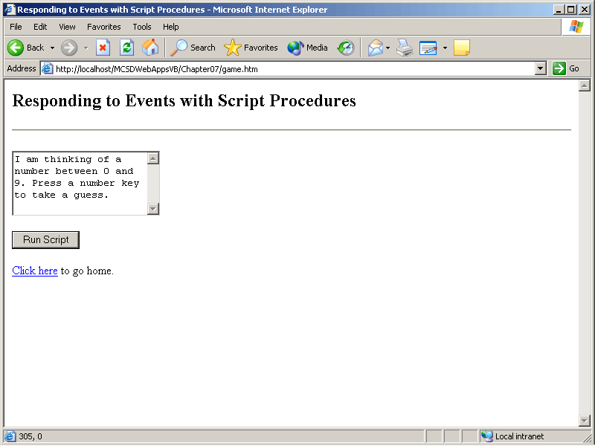
Figure 7-11. The guessing game
Sending Mail
To send mail using the client’s mail system, create a hyperlink using the Mailto protocol. For example, the following HTML shows a hyperlink that creates a new message with a subject line and a short message body:
<A href="mailto:someone@microsoft.com?SUBJECT=Sending from a client&BODY=Some message text.">
When the user clicks this hyperlink, the client’s browser starts the client’s mail application and creates a message. You can use the Mailto protocol in place of any destination URL in a server control or an HTML control. For instance, the following HTML defines a Hyperlink server control that sends a mail message:
<asp:HyperLink ID="hypMail" NavigateUrl="mailto:someone@microsoft.com?
SUBJECT=Mailing a Webform&amp;BODY=Some message text."
Runat="server">Send mail.</ asp:HyperLink>
To send mail from the server, use the SmtpMail class from server-side code. The SmtpMail class does not start the client’s mail system to allow the user to compose the message to send, to add attachments, or to validate addresses. Instead, you compose the message in code and send it one of two ways:
- You can send a simple message using the SmtpMail class’s Send method.
- You can create a more complex message using the MailMessage class and then send that message using the SmtpMail class’s Send method.
Both the SmtpMail class and the MailMessage class are part of the System.Web.Mail namespace in the .NET Framework, so add the following statement at the beginning of your module to simplify references to those classes in code:
Visual Basic .NET
Imports System.Web.Mail
Visual C#
using System.Web.Mail;
You don’t need to create an instance of the SmtpMail class before using it. To send a simple message, just use the Send method, as shown here:
Visual Basic .NET
SmtpMail.Send ("someone@microsoft.com", "jesse@contoso.com",
"Subject line", _
"Message text.")
Visual C#
SmtpMail.Send("someone@microsoft.com", "jesse@contoso.com", "Subject line",
"Message text.");
The preceding line of code immediately sends a message from someone@microsoft.com to jesse@contoso.com. Both the from and to addresses are required, although they are not validated by the Send method. The SmtpMail class sends mail using your local SMTP server by default. To use a different server, set the SmtpServer property.
Using the Send method alone is fine for simple text messages, but to send a formatted message or a message containing an attachment, you need to create an object based on the MailMessage class and then use the SmtpMail class’s Send method to send the message, as shown in the following code:
Visual Basic .NET
Private Sub butMail_Click(ByVal sender As System.Object, _
ByVal e As System.EventArgs) Handles butMail.Click
' Create the message.
Dim mailNew As New MailMessage()
' Set the message properties.
mailNew.From = "someone@microsoft.com"
mailNew.To = "jesse@contoso.com"
mailNew.Subject = "This is the subject text."
mailNew.Body = "This is the message text."
' Create an attachment.
Dim atcItem As New _
MailAttachment(Server.MapPath(".") & "\joey.jpg")
' Attach it to the message.
mailNew.Attachments.Add(atcItem)
' Send the message.
SmtpMail.Send(mailNew)
End Sub
Visual C#
private void butSendMail_Click(object sender, System.EventArgs e)
{
// Create the message.
MailMessage mailNew = new MailMessage();
// Set the message properties.
mailNew.From = "someone@microsoft.com";
mailNew.To = "jesse@contoso.com";
mailNew.Subject = "This is the subject text.";
mailNew.Body = "This is the message text.";
// Create an attachment.
MailAttachment atcItem = new MailAttachment
(Server.MapPath(".") +
"\\joey.jpg");
// Attach it to the message.
mailNew.Attachments.Add(atcItem);
// Send the message.
SmtpMail.Send(mailNew);
}
This code creates a message, sets the message properties, attaches a file to the message, and sends the message. As with the previous Send method example, the From and To properties are required but are not validated.
Lesson 5: Consuming XML Web Services
XML Web services are business logic components that can be accessed over the Internet. Consuming a Web service simply means using that service from within your application. In this lesson, you’ll learn how to locate, reference, and use XML Web services from a Web application.
After this lesson, you will be able to
- Search for XML Web services by company name
- Add a reference to an XML Web service from a Visual Studio .NET project
- Use an XML Web service from within a Web application
- Use an XML Web service from client-side scripts
- Use a licensed XML Web service
Estimated lesson time: 15 minutes
Finding XML Web Services
XML Web services are made public over the Web using a Universal Description, Discovery, and Integration (UDDI) registry. Currently, Microsoft and IBM manage two UDDI registry nodes available for locating XML Web services. Businesses register their Web services on these nodes so that customers (you and I) can locate the Web services they want to use.
There are many different ways to search for XML Web services on the Internet. The easiest way is just to select XML Web Services from the Start Page in Visual Studio .NET, as shown in Figure 7-12.
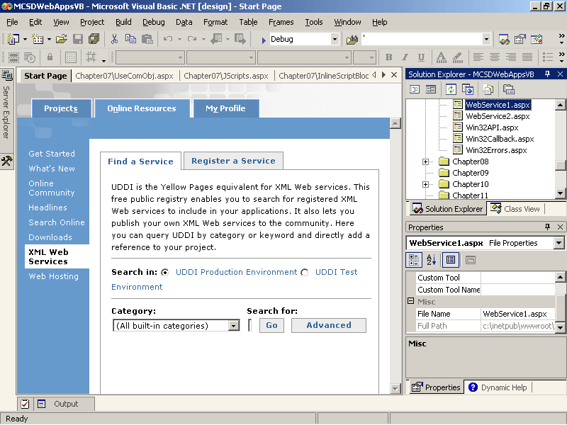
Figure 7-12. Finding XML Web services
The XML Web Services item on the Start Page lets you locate XML Web services by general category of task that the service performs, such as calendar, financial, math, or weather. The Search In option buttons above the Category box let you search for XML Web services that have been put into production (presumably these have been debugged and tested) or are still under development.
In some cases, a Web service might be available to the public but not listed in the UDDI registry. In these cases, you must know the address of the Web service. This information is often listed on the Web site of the company that offers the service, usually under a heading such as Developer Tools.
Using an XML Web Service
Using an XML Web service is much the same as using a .NET or COM component: you establish a reference to the class, create an instance of an object from the class, and then use the object’s properties and methods within your code. There are several ways to establish a reference to an XML Web service from within Visual Studio .NET; perhaps the easiest is to do so from the Start Page.
To reference XML Web services from the Visual Studio .NET Start Page, follow these steps:
- Find the XML Web service you want to use by clicking the XML Web Services link on the Online Resources tab on the Start Page in Visual Studio .NET.
- Click the Add As Web Reference To Your Current Project hyperlink underneath the XML Web service description. Visual Studio adds a Web reference to the Web References section of Solution Explorer, as shown in Figure 7-13.
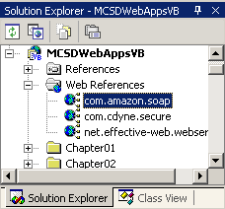
Figure 7-13. Web references
To use the reference in code, follow these steps:
- Create a new object from the XML Web service class. The XML Web service class name is displayed in the Web References folder of Solution Explorer.
- Use the XML Web service’s properties and methods from the new object. XML Web service classes work with Visual Studio’s autocomplete and Object Browser features, so using XML Web service properties and methods is the same as for any other object.
NOTE
The following example depends on the availability of a third-party Web site. At the time this book was written, this Web site was available. However, its future availability can’t be guaranteed.
For example, the following code uses the CDYNE Credit Card Checker Web service to validate a credit card number entered in a text box:
Visual Basic .NET
Private Sub butCheck_Click(ByVal sender As System.Object, _
ByVal e As System.EventArgs) Handles butCheck.Click
Dim wsCheck As New com.cdyne.secure.LUHNChecker()
Dim wsValid As com.cdyne.secure.ReturnIndicator
wsValid = wsCheck.CheckCC(txtNumber.Text)
lblMsg.Text = wsValid.CardType & " " & wsValid.CardValid.ToString()
End Sub
Visual C#
private void butCheck_Click(object sender, System.EventArgs e)
{
com.cdyne.secure.LUHNChecker wsCheck = new com.cdyne.secure.LUHNChecker();
com.cdyne.secure.ReturnIndicator wsValid;
wsValid = wsCheck.CheckCC(txtNumber.Text);
lblMsg.Text = wsValid.CardType + " " + wsValid.CardValid.ToString();
}
Using XML Web Services from Client-Side Scripts
In some cases, it makes more sense to call an XML Web service from client-side scripts than from server code. An XML Web service might take a long time to respond—there’s no point in making the server wait for the response when the server is just going to pass that response on to the client anyway.
To use an XML Web service from client-side scripts, follow these steps:
- Create a style class for the WebService behavior (Webservice.htc).
- Add an HTML element to the page that uses the class you created in step 1.
- Write script procedures to initialize and call methods on the XML Web service using the XML Web service behavior.
The following HTML creates a webservice style class and then initializes and calls a Web service to display a daily quote when the user clicks Show Quote:
VBScript
<HTML>
<HEAD>
<title>WebForm2</title>
<style>
.webservice { BEHAVIOR:url(webservice.htc) }
</style>
<script language="VBScript">
Dim iCallID

Sub init(control, wsAddress, name)
control.useService wsAddress, name
End Sub

Function getResult()
if window.event.result.error And (iCallID = window.event.result.id) Then
Dim xfaultcode, xfaultstring, xfaultsoap
xfaultcode = window.event.result.errorDetail.code
xfaultstring = window.event.result.errorDetail.string
xfaultsoap = window.event.result.errorDetail.raw
' Display error information.
alert("Error " & xfautlcode & " │ " & xfaultstring & " │ " & xfaultSoap)
Else
getResult = window.event.result.value
End If
End Function

Sub getQuote()
' Initialize Web service on the selected control.
init ws, "http://webservice.effective-web.net/globalself/
globalselfDailyThought.WSDL", "DailyQuote"
' Call a method within the Web service.
iCallID = ws.DailyQuote.callService("getTodaysQuote")
' Result is displayed in the ws div element by onresult.
End Sub
</script>
</HEAD>
<body>
<form id="WebForm2" method="post" runat="server">
<h2>Using Web Services from Client-Side Code</h2>
<div id="ws" class="webservice"
onresult="ws.innerText = getResult()"></div>
<br>
<input type="button" onclick="getQuote()" value="Get Quote">
</form>
</body>
</HTML>
JScript
<HTML>
<HEAD>
<title>WebForm2</title>
<style>
.webservice { BEHAVIOR:url(webservice.htc) }
</style>
<script language="JScript">
var iCallID;

function init(control, wsAddress, name)
{
control.useService(wsAddress, name);
}

function getResult()
{
if((event.result.error)&&(iCallID==event.result.id))
{
var xfaultcode = event.result.errorDetail.code;
var xfaultstring = event.result.errorDetail.string;
var xfaultsoap = event.result.errorDetail.raw;
// Display error information.
alert("Error " + xfautlcode + " │ " + xfaultstring + " │ " + xfaultSoap);
}
else
{
return event.result.value;
}
}

function getQuote()
{
// Initialize Web service on the selected control.
init(ws, "http://webservice.effective-web.net/globalself/
globalselfGlobalSelf.WSDL", "DailyQuote");
// Call a method within the Web service.
iCallID = ws.DailyQuote.callService("getTodaysQuote");
// Result is displayed in the ws div element by onresult.
}
</script>
</HEAD>
<body>
<form id="WebForm2" method="post" runat="server">
<h2>Using Web Services from Client-Side Code</h2>
<div id="ws" class="webservice"
onresult="ws.innerText = getResult();"></div>
<br>
<input type="button" onclick="getQuote()" value="Get Quote">
</form>
</DIV>
</body>
</HTML>
For more information about using XML Web services from client-side scripts, search for “Web Service Behavior” in the Visual Studio online Help.
Using Licensed XML Web Services
The preceding XML Web service examples are available on the Internet for free as demonstrations. Other services might require a license in order to charge a fee for their use or to control and track who is using their services.
The XML Web services provided by Amazon.com and Google are good examples of XML Web services that require a license. Neither XML Web service charges for use at this time—in fact, Amazon.com actually credits users through their associates program. Instead, these companies use licensing to establish rules of use and to keep in touch with the developers using their services.
To use a licensed Web service, follow these steps:
- Visit the Web service developer’s Web site, and complete the requested license information.
- Reference the XML Web service using the address of the Web Services Description Language (WSDL) file. Licensed XML Web services are often not listed in the UDDI.
- Use the XML Web service methods.
For example, you can get the Amazon XML Web service information from the following address: http://www.amazon.com/webservices. You can download the XML Web service documentation from that address and apply for a developer’s token that allows you to use the service. Once you have a developer’s token, you use it in code to call the XML Web service methods. The Amazon.com XML Web service is available from this address: http://soap.amazon.com/schemas2/AmazonWebServices.wsdl.
Once you establish a Web reference to the preceding address, you can use the Web service, as shown in the following code:
Visual Basic .NET
Private Sub Page_Load(ByVal sender As System.Object, _
ByVal e As System.EventArgs) Handles MyBase.Load
' Declare an object to represent the Web Service.
Dim wsAmazon As New com.amazon.soap.AmazonSearchService
' Declare a structure to pass search criteria in.
Dim Search As New com.amazon.soap.KeywordRequest
' Set the search criteria.
Search.keyword = "ASP.NET"
' This is the special license number issued to developers.
' Get your own from Amazon.
Search.devtag = "DT7Y0UZAPK4PI"
' This is the associates ID for Amazon partners. Get your
' own number from Amazon if you wish to get credit for sales.
Search.tag = "webservices-20"
' This property determines how much detail is returned.
Search.type = "heavy"
' Which version of the Web Service to use.
Search.mode = "books"
' Get the ProductInfo from the Web Service.
Dim Info As com.amazon.soap.ProductInfo = _
wsAmazon.KeywordSearchRequest(Search)
' Declare a variable to use with For Each iteration.
Dim Book
' Go through the returned ProductInfo array.
For Each Book In Info.Details
'Insert an image of the cover.
litResult.Text += "<h4>Amazon Sales Rank: " & Book.SalesRank &_
litResult.Text += "</h4><img src='" & Book.ImageUrlMedium & "'>"
Next
End Sub
Visual C#
private void Page_Load(object sender, System.EventArgs e)
{
// Declare an object to represent the Web Service.
com.amazon.soap.AmazonSearchService wsAmazon =
new com.amazon.soap.AmazonSearchService();
// Declare a structure to pass search criteria in.
com.amazon.soap.KeywordRequest Search =
new com.amazon.soap.KeywordRequest();
// Set the search criteria.
Search.keyword = "ASP.NET";
// This is the special license number issued to developers.
// Get your own from Amazon.
Search.devtag = "DT7Y0UZAPK4PI";
// This is the associates ID for Amazon partners. Get your
// own number from Amazon if you wish to get credit for sales.
Search.tag = "webservices-20";
// This property determines how much detail is returned.
Search.type = "heavy";
// Which version of the Web Service to use.
Search.mode = "books";
// Get the ProductInfo from the Web Service.
com.amazon.soap.ProductInfo Info =
wsAmazon.KeywordSearchRequest(Search);
// Go through the returned ProductInfo array.
foreach(com.amazon.soap.Details Book in Info.Details)
{
//Insert an image of the cover.
litResult.Text += "<h4>Amazon Sales Rank: " +
Book.SalesRank + "</h4>";
litResult.Text += "<img src='" + Book.ImageUrlMedium + "'>";
}
}
The Amazon.com Web service documentation provides a practical guide to using their Web service in different ways and in a variety of languages.
Summary
- Cookies enable you to invisibly save information about a particular user. Cookies can be used to save the information directly on the user’s computer or indirectly through a unique identifier, which is then referenced to retrieve user information from a data set stored on the server.
- Use the Request object’s Cookies collection to retrieve a cookie from the user. Use the Response object’s Cookies collection to create or modify a cookie on the user’s computer.
- Set the Cookie object’s Expires property to Now to delete a cookie from the user’s computer.
- Use the DllImport attribute to declare unmanaged procedures for use within .NET assemblies.
- Create a reference to a COM object in Visual Studio to automatically create an interop assembly that allows you to use the COM object within .NET code.
- To hide public .NET members from COM, use the ComVisible attribute.
- Select a .NET class library project’s Register For COM Interop build check box to automatically create a type library for the project and register the assembly with the system registry.
- Client-side scripts let you control the browser window, respond immediately to non-postback events, and perform other tasks that are not possible from server-side code.
- Use the Browser object’s VBScript or JavaScript properties to test whether the browser can run scripts. Use an inline test script that redirects the users to another page to test whether a user has disabled scripting through his or her browser security settings.
- Add script event procedures to a page’s HTML to respond to events that occur on the client side rather than the server side.
- Use the Mailto protocol to create a message that will be sent from the user’s mail system. The Mailto protocol is used as part of a hyperlink.
- Use the MailMessage and SmtpMail classes to compose and send messages from the server’s mail system.
- Create a Web reference to use an XML Web service from server-side code.
- Use the WebService behavior to use an XML Web service from client-side code.
Lab: Using Advanced Features
In this lab, you’ll create an application that displays multiple pages using frames. This application lets users choose a background color for the application, compose and send mail from the server, and play a simple game. The Advanced Features application demonstrates these key features:
- Testing browser capabilities to make sure a user’s browser supports frames, cookies, and scripts
- Saving cookies on the user’s computer and then retrieving those cookies to set the background color for the application
- Sending mail from the server using the MailMessage and SmtpMail objects
- Displaying pages in frames and controlling the display of those frames from a Contents page
- Optionally including Web forms that use the Win32 API, COM objects, and XML Web services
When complete, the Advanced Features application will appear as shown in Figure 7-14.
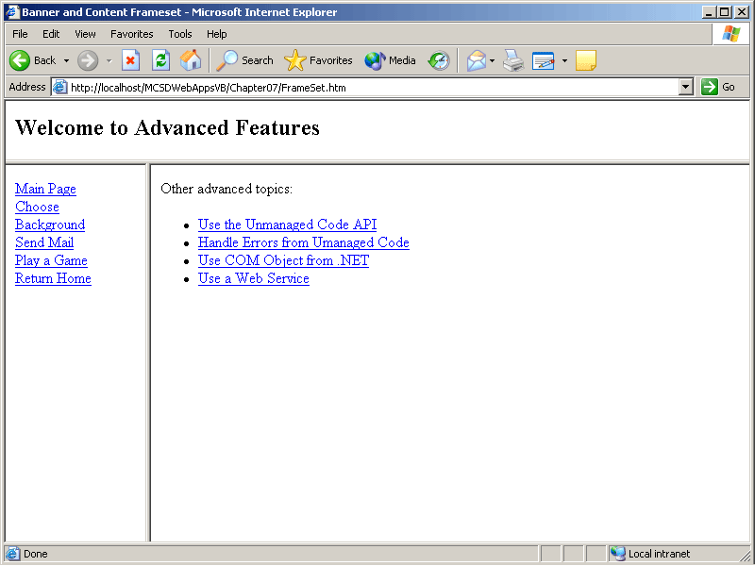
Figure 7-14. The Advanced Features application
Estimated lesson time: 45 minutes
Exercise 1: Check Advanced Feature Support

In this exercise, you’ll create a default page for an application that checks to see whether the user’s browser accepts cookies, can display frames, and runs scripts. If any of these features are not available, an appropriate message is displayed.
A default page is a page that Internet Information Services (IIS) displays if the user navigates to the Web application directory without specifying a particular page to view. IIS uses the names Default.htm and Default.aspx for the default page unless you change them for the application through IIS.
To create a default page that checks the user’s browser for advanced feature support
- Add a Web form to your application named Default.aspx, and make that page the start page for your application.
- Add the following Page_Load event procedure to the Web form:
Visual Basic .NET
Private Sub Page_Load(ByVal sender As System.Object, _
ByVal e As System.EventArgs) Handles MyBase.Load
' Create a flag to track if any advanced features are disabled.
Dim bProceed As Boolean = True
' Check if browser accepts cookies.
If Request.Browser.Cookies = False Then
Response.Write("Your browser does not accept cookies.<br>" & _
"Change your browser's security settings allow cookies." & _
"<br><br>")
bProceed = False
End If
' Check if browser supports scripting.
If Request.Browser.JavaScript = False Then
Response.Write("Your browser does not support scripts.<br>" & _
"Update your browser software to the latest version.<br><br>")
bProceed = False
End If
' Check if browser supports VBScript.
If Request.Browser.VBScript = False Then
Response.Write("Your browser does not support VBScript.<br>" & _
"Install the latest version of Internet Explorer.<br><br>")
bProceed = False
End If
' If browser passes other tests, see if scripting is enabled by
' trying a script.
If bProceed Then
' If scripts are disabled, the following line is ignored.
' Otherwise, it displays the frameset.
Response.Write("<script>window.navigate('frameset.htm')</script>")
Response.Write("Scripting is disabled due to your browser " & _
"security settings.<br> Change your browser's security " & _
"settings allow scripting.<br><br>")
End If
End Sub
Visual C#
private void Page_Load(object sender, System.EventArgs e)
{
// Create a flag to track if any advanced features are disabled.
bool bProceed = true;
// Check if browser accepts cookies.
if (!Request.Browser.Cookies)
{
Response.Write("Your browser does not accept cookies.<br>" +
"Change your browser's security settings allow cookies." +
"<br><br>");
bProceed = false;
}
// Check if browser supports scripting.
if (!Request.Browser.JavaScript)
{
Response.Write("Your browser does not support scripts.<br>" +
"Update your browser software to the latest " +
"version.<br><br>");
bProceed = false;
}
// Check if browser supports VBScript.
if (!Request.Browser.VBScript)
{
Response.Write("Your browser does not support VBScript.<br>" +
"Install the latest version of Internet Explorer.<br><br>");
bProceed = false;
}
// If browser passes other tests, see if scripting is enabled by
// trying a script.
if (bProceed)
{
// If scripts are disabled, the following line is ignored.
// Otherwise, it displays the frameset.
Response.Write("<script>window.navigate('frameset.htm')" +
"</script>");
Response.Write("Scripting is disabled due to your browser " +
"security settings.<br> Change your browser's security " +
"settings to allow scripting.<br><br>");
}
}
- Add the following HTML content to the Web form:
- <p>This Web application uses features that are either not available in
- your browser or are disabled through your browser's security settings.
- You cannot run this application until you update your browser as described
above. Then click <a href="default.aspx">here</a> to try again.</p>
When the default page you created with the preceding steps loads, it checks each of the advanced features that a browser might or might not support. If there are problems using any of those features, the page displays a warning message, as shown in Figure 7-15.
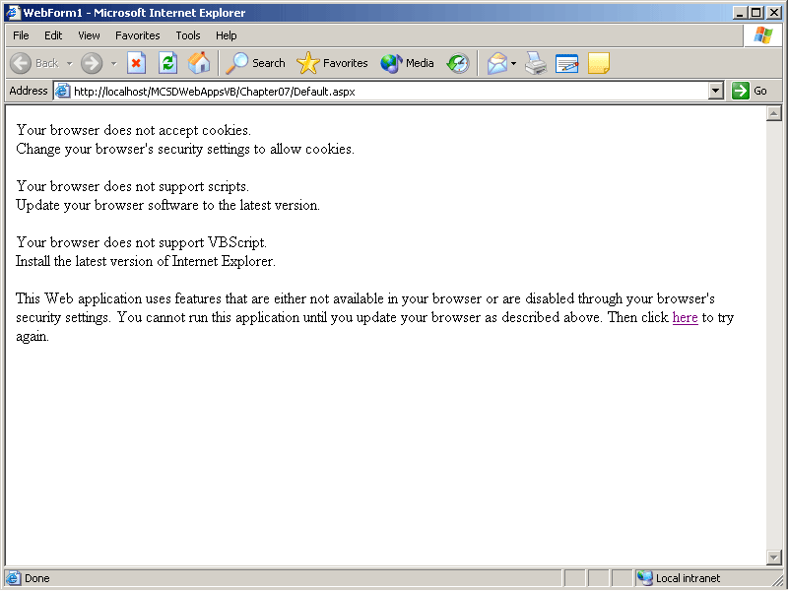
Figure 7-15. Warning message
If no problems are encountered, the user never sees the default page. Instead, he or she is redirected immediately to frameset.htm, which displays the other pages in the application.
Exercise 2: Store User Information
In this exercise, you’ll create a Web form that allows the user to select a background color. The form “remembers” the user’s choice between sessions by saving the background in a cookie on the user’s machine. When complete, the Web form will appear as shown in Figure 7-16.
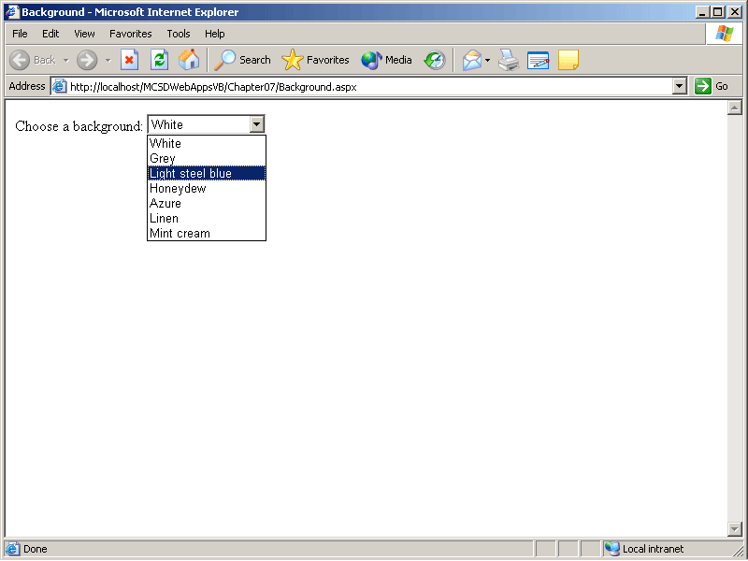
Figure 7-16. The Background.aspx Web form
To create the Background Web form
- Create a new Web form named Background.aspx.
- Add a DropDownList server control to the Web form containing list items for some different background colors. This step is probably easier to do in HTML than in Design mode, because you can use cut and paste to create the list items quickly in HTML. The following HTML shows the definition for the DropDownList and its list items:
- <asp:dropdownlist id="drpBackground" AutoPostBack="True" Runat="server" Width="128px">
- <asp:ListItem Value="White">White</asp:ListItem>
- <asp:ListItem Value="Silver">Grey</asp:ListItem>
- <asp:ListItem Value="LightSteelBlue">Light steel blue</asp:ListItem>
- <asp:ListItem Value="Honeydew">Honeydew</asp:ListItem>
- <asp:ListItem Value="Azure">Azure</asp:ListItem>
- <asp:ListItem Value="Linen">Linen</asp:ListItem>
- <asp:ListItem Value="MintCream">Mint cream</asp:ListItem>
</asp:dropdownlist>
- Modify the Web form’s <body> element to specify a background color using data binding from the DropDownList. The following HTML shows the changes to the <body> element:
<body bgColor="<%# drpBackground.SelectedItem.Value %>">
- Add the following code to the Page_Load event procedure to check for a cookie, create the cookie if it does not exist, or set the background color from the cookie if it does exist. The Page_Load event procedure also performs data binding for the page to update the background color.
Visual Basic .NET
Private Sub Page_Load(ByVal sender As System.Object, _
ByVal e As System.EventArgs) Handles MyBase.Load
' On first display
If IsPostBack = False Then
' Check if cookie doesn't exist...
If Request.Cookies("BackgroundColor") Is Nothing Then
' Create a cookie with the default background color.
Dim cookBackground As New HttpCookie("BackgroundColor", "0")
' Set the cookie to expire in one day.
cookBackground.Expires = DateTime.Now.AddDays(1)
' Add the cookie to the response object.
Response.Cookies.Add(cookBackground)
Else
' Get the user's background color from the cookie.
drpBackground.SelectedIndex = _
CInt(Request.Cookies("BackgroundColor").Value)
End If
End If
' Update bound field to set background color
Page.DataBind()
End Sub
Visual C#
private void Page_Load(object sender, System.EventArgs e)
{
// On first display
if (!IsPostBack)
{
// If cookie doesn't exist...
if (Request.Cookies["BackgroundColor"] == null)
{
// Create a cookie with the default background color.
HttpCookie cookBackground = new
HttpCookie("BackgroundColor", "0");
// Set the cookie to expire in one day.
cookBackground.Expires = DateTime.Now.AddDays(1);
// Add the cookie to the response object.
Response.Cookies.Add(cookBackground);
}
else
{
// Get the user's background color from the cookie.
drpBackground.SelectedIndex =
Convert.ToInt16(Request.Cookies["BackgroundColor"]
.Value);
}
}
// Update bound field to set background color
Page.DataBind();
}
- Add the following code to update the cookie through the Response object when the user selects a background color from the DropDownList:
Visual Basic .NET
Private Sub drpBackground_SelectedIndexChanged(ByVal sender As _
System.Object, ByVal e As System.EventArgs) Handles _
drpBackground.SelectedIndexChanged
' Record color selection in a cookie.
Dim cookBackground As New HttpCookie("BackgroundColor")
' Set the cookie's value.
cookBackground.Value = drpBackground.SelectedIndex
' Set the cookie's expiration.
cookBackground.Expires = DateTime.Now.AddDays(1)
' Add the cookie to the Response object.
Response.Cookies.Add(cookBackground)
End Sub
Visual C#
private void drpBackground_SelectedIndexChanged(object sender,
System.EventArgs e)
{
// Record color selection in a cookie.
HttpCookie cookBackground = new HttpCookie("BackgroundColor");
// Set the cookie's value.
cookBackground.Value = drpBackground.SelectedIndex.ToString();
// Set the cookie's expiration.
cookBackground.Expires = DateTime.Now.AddDays(1);
// Add the cookie to the Response object.
Response.Cookies.Add(cookBackground);

}
Exercise 3: Create a Mail Web Form
In this exercise, you’ll create a Web form that allows you to compose and send a mail message from the server. When complete, the Mail Web form will appear as shown in Figure 7-17.
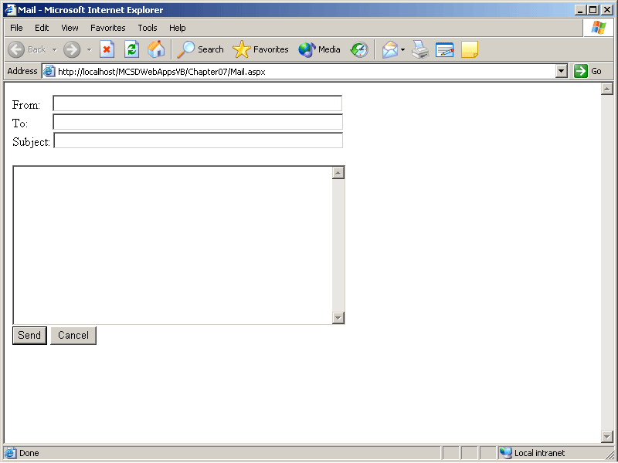
Figure 7-17. The Mail.aspx Web form
To create the Mail Web form
- Create a new Web form named Mail.aspx.
- Add text and server controls to the Web form, as shown in the following HTML:
- <P>
- From:&nbsp;&nbsp;&nbsp;
- <asp:TextBox ID="txtFrom" Runat="server" Width="376px"></asp:TextBox>
- <asp:RequiredFieldValidator ID="vldtxtFrom" ControlToValidate="txtFrom"
- Runat="server" ErrorMessage="Required field.">
- </asp:RequiredFieldValidator>
- <br>
- To:&nbsp;&nbsp;&nbsp;&nbsp;&nbsp;&nbsp;&nbsp;
- <asp:TextBox ID="txtTo" Runat="server" Width="377px"></asp:TextBox>
- <asp:RequiredFieldValidator ID="vldTo" ControlToValidate="txtTo"
- Runat="server" ErrorMessage="Required field.">
- </asp:RequiredFieldValidator>
- <br>
- Subject:
- <asp:TextBox ID="txtSubject" Runat="server" Width="376px"></asp:TextBox>
- </P>
- <asp:TextBox ID="txtMessage" Runat="server" TextMode="MultiLine" Width="432px"
- Height="208px"></asp:TextBox>
- <br>
- <asp:Button ID="butSend" Runat="server" Text="Send"></asp:Button>
- <input type="reset" id="butReset" value="Cancel">
- <br>
<asp:literal id="litStatus" runat="server"></asp:literal>
The RequiredFieldValidator controls in the preceding HTML are needed because the From and To properties of the MailMessage object must be set before the message can be sent.
- Add the following Imports or using statement to the beginning of the Web form’s code module so that you can use short names for members of the System.Web.Mail namespace:
Visual Basic .NET
Imports System.Web.Mail
Visual C#
using System.Web.Mail;
- Add the following code to the butSend_Click event procedure to create a MailMessage object and to send the message from the server:
Visual Basic .NET
Private Sub butSend_Click(ByVal sender As System.Object, _
ByVal e As System.EventArgs) Handles butSend.Click
' Create message.
Dim msgMail As New MailMessage()
' Set message properties.
msgMail.From = txtFrom.Text
msgMail.To = txtTo.Text
msgMail.Subject = txtSubject.Text
msgMail.Body = txtMessage.Text
' Send message.
SmtpMail.Send(msgMail)
' Clear To, Subject, and Message fields.
txtTo.Text = ""
txtSubject.Text = ""
txtMessage.Text = ""
' Show success.
litStatus.Text = "<p>Message sent.</p>"
End Sub
Visual C#
private void butSend_Click(object sender, System.EventArgs e)
{
// Create message.
MailMessage msgMail = new MailMessage();
// Set message properties.
msgMail.From = txtFrom.Text;
msgMail.To = txtTo.Text;
msgMail.Subject = txtSubject.Text;
msgMail.Body = txtMessage.Text;
// Send message.
SmtpMail.Send(msgMail);
// Clear To, Subject, and Message fields.
txtTo.Text = "";
txtSubject.Text = "";
txtMessage.Text = "";
// Show success.
litStatus.Text = "<p>Message sent.</p>";
}
- Add the following code to the Page_Load event procedure to clear the status message if the user cancels sending a message after successfully sending an earlier message:
Visual Basic .NET
Private Sub Page_Load(ByVal sender As System.Object, _
ByVal e As System.EventArgs) Handles MyBase.Load
' Clear status message.
litStatus.Text = ""
End Sub
Visual C#
private void Page_Load(object sender, System.EventArgs e)
{
// Clear status message.
litStatus.Text = "";
}
Exercise 4: Create a Frame-Based User Interface
In this exercise, you’ll create a frameset containing regions for a table of contents, a banner, and a body. You’ll create a table of contents page that displays selected pages in the body frame and updates the banner frame using a script. When complete, the frameset will appear as shown in Figure 7-18.
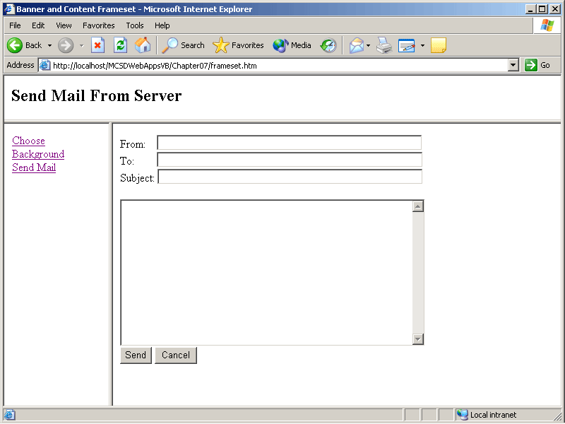
Figure 7-18. The completed frameset at run time
To create the frame-based user interface
- Create a new HTML page named Contents.htm.
- Add the following hyperlinks to the Contents page:
- <a href="Background.aspx" target="main"
- onclick="ShowBanner('Choose Background')">Choose Background</a>
- <br>
- <a href="Mail.aspx" target="main"
- onclick="ShowBanner('Send Mail From Server')">Send Mail</a>
<br>
The hyperlinks shown in the preceding HTML provide a way to navigate to the other pages in the application and will display those pages in the main frame of the frameset you will create in the following steps.
- Add the following script procedure to the Contents page:
VBScript
<script language="vbscript">
' Updates the text in the banner frame.
Sub ShowBanner(Message)
' Write text to banner frame.
parent.frames("banner").document.write("<h2>" & Message & "</h2>")
' Close document so next write replaces the current text.
parent.frames("banner").document.close
End Sub
</script>
JScript
<script language="javascript">
// Updates the text in the banner frame.
function ShowBanner(Message)
{
// Write text to banner frame.
parent.frames["banner"].document.write("<h2>" + Message + "</h2>");
// Close document so next write replaces the current text.
parent.frames["banner"].document.close();
}
</script>
This ShowBanner script displays a title in the banner frame of the frameset from each of the hyperlinks created in step 2.
- Create a frameset in which to display the project pages. From the Project menu, choose Add New Item, and then select Frameset from the Templates list and name the file Frameset.htm. When you click Open, Visual Studio displays the Select A Frameset Template dialog box.
- Select the Banner And Content frameset template and click OK. Visual Studio displays a new, empty frameset in the Design window.
- Right-click in the leftmost frame, and select Set Page For Frame from the shortcut menu. Visual Studio displays the Select Page dialog box.
- Select Contents.htm in the Select Page dialog box, and click OK to display the Contents page in the frame.
- Make the frameset the start page for the application. In Solution Explorer, right-click the Frameset.htm file, and select Set As Start Page from the shortcut menu.
Exercise 5: Extra Practice Using Advanced Features
Exercises 1 through 4 walked you through some of the tasks you explored in this chapter. Now strike out on your own by attempting to complete the following tasks that extend the Advanced Features application:
- Add a Web form that displays information using a COM object from your system or the ShapesCOM object included on the companion CD.
- Add a Web form that uses the SystemInfo Win32 API to display system information or select another unmanaged procedure to call through platform invoke.
- Add a Window_OnLoad script to the Contents page to display a welcome message in the banner frame the first time the page is displayed.
- Add the Guess A Number Web form created at the end of Lesson 4 to the Advanced Features application.
- Create a cookie within the Mail Web form to remember the From address entered by the user.
- Use the background color set on the Background Web form to change the background color displayed on each page in the frameset.
When you have finished, compare your results to the Advanced Features application included on the companion CD. Good luck!
Review
The following questions are intended to reinforce key information presented in this chapter. If you are unable to answer a question, review the appropriate lesson and then try the question again. Answers to the questions can be found in the appendix.
- Write the HTML for a hyperlink that will send mail when the user clicks the link.
- Write the code that creates a cookie containing the user name Rob Young and the current date to the user’s computer. Set the cookie to remain on the user’s computer for 30 days.
- What attribute do you use to hide a public .NET class from COM?
- Why can’t you open a new browser window using server-side code? How would you display a page in a new window with a client-side script?
- How do you declare an unmanaged procedure within .NET?

